**Model With Kids Learning**

## A PROJECT REPORT

## for

**Project (KCA451)**

**Session (2023-24)**

**Submitted By**

## Vaibhav Tiwari

## 2200290140173

**Vandana Tiwari 2200290140174**

## Submitted in partial fulfilment of the Requirements for the Degree of

MASTER OF COMPUTER APPLICATION

## Under the Supervision of Dr. Ankit Verma (Associate Professor)



**Submitted to**

**DEPARTMENT OF COMPUTER APPLICATIONS**

## KIET Group of Institutions, Ghaziabad Uttar Pradesh-201206

**(June 2024)**

## CERTIFICATE

Certified that **Vaibhav Tiwari (2200290140173), Vandana Tiwari (2200290140174)** has/ have carried out the project work having **Model with Kids Learning** **(Project-KCA451)** for **Master of Computer Application** from Dr. A.P.J. Abdul Kalam Technical University (AKTU**)** (formerly UPTU), Technical University, Lucknow under my supervision. The project report embodies original work, and studies are carried out by the student himself / herself and the contents of the project report do not form the basis for the award of any other degree to the candidate or to anybody else from this or any other University/Institution.

**Date:**

**Vaibhav Tiwari (2200290140173) Vandana Tiwari (2200290140174)**

This is to certify that the above statement made by the candidate is correct to the best of my knowledge.

Date:

**Dr. Ankit Verma Dr. Arun Kumar Tripathi**

**Associate Professor Head**

**Department of Computer Applications Department of Computer Applications**

**KIET Group of Institutions, Ghaziabad KIET Group of Institutions, Ghaziabad**

**Model with Kids Learning**

**Vaibhav Tiwari**

**Vandana Tiwari**

## “ABSTRACT”

Model With Kids Learning app developed on the Unity platform, designed to make education an exciting journey for young minds. This app offers a diverse range of interactive and entertaining activities, fostering a love for learning while covering key educational concepts.

With colorful and immersive visuals, children embark on educational quests, solving puzzles, playing games, and exploring various subjects in a playful environment. The Unity-based app ensures a seamless and user-friendly experience, combining the power of technology with educational content to create a dynamic and enjoyable learning atmosphere.

Model With Kids Learning not only focuses on academic subjects but also incorporates essential life skills, encouraging creativity, critical thinking, and problem-solving. Parents and educators can track progress, providing valuable insights into a child's learning journey.

This innovative Unity-based app aims to revolutionize the way children perceive learning, making it an enjoyable and interactive experience that sparks curiosity and nurtures a lifelong love for knowledge. Technological advances brought applications of innovations to education with new technologies accompanied by more learner active environments using QR Codes by using the Internet. There are learners preferring self-learning. Traditional learning materials have been upgraded to be more appealing, motivational, and technologically advanced. The main aim to develop this AR application for understanding particular word to make learning more interesting and easier for students.

.

## ACKNOWLEDGEMENT

Success in life is never attained single handedly. My deepest gratitude goes to my Report supervisor, **Dr. Ankit Verma** for his guidance, help and encouragement throughout my research work. Their enlightening ideas, comments, and suggestions.

Words are not enough to express my gratitude to **Dr. Arun Kumar Tripathi, Professor and Head, Department of Computer Applications,** for his insightful comments and administrative help at various occasions.

Fortunately, I have many understanding friends, who have helped me a lot on many critical conditions.

Finally, my sincere thanks go to my family members and all those who have directly and indirectly provided me moral support and other kind of help. Without their support, completion of this work would not have been possible in time. They keep my life filled with enjoyment and happiness.

**Vaibhav Tiwari (2200290140173)**

**Vandana Tiwari (2200290140174)**

## TABLE OF CONTENTS

Certificate ii

Abstract iii

Acknowledgements iv

Table of Contents v

List of Figures vi

Chapter 1 –Introduction 8

* 1. Project Description 8
  2. Project Scope 9
  3. Hardware/Software used in Project 10

Chapter 2 –Feasibility Study 11

* 1. Technical feasibility 11
  2. Operational feasibility 11
  3. Behavioral feasibility 12

Chapter 3 –Database Design 13

* 1. Database Table 14
  2. Flow Diagram 15

Chapter 4– App Design 18

* 1. Project Screen Layout (Screenshot) 19
  2. Sample Scene (Screenshot) 20
  3. Directional Light (Screenshot) 21
  4. AR Camera (Screenshot) 22
  5. Image (Screenshot) 23

Chapter 5–Testing 44

5.1Introduction 45

5.2Type of Testing 46

Chapter 6–Conclusion 47

Chapter 7–References 48

## LIST OF FIGURES

|  |  |  |
| --- | --- | --- |
| **Figure No.** | **Name of Figure** | **Page No.** |
| 3.1 | Admin | 15 |
| 3.2  3.4  4.1  4.2  4.3  4.4  4.5  4.6  4.7  4.8  4.9  4.10  4.11  4.12  4.13  4.14  4.15  4.16  4.17  4.18  4.19  4.20  4.21  4.22  4.23  4.24  4.25  4.26  4.27  4.28  4.29  4.30  4.31  4.32  4.33  4.34  4.35  4.36  4.37  4.38  4.39  4.40  4.41  4.42  4.43 | User  Flowchart  Project Screen Layout  Sample Scene  Directional Light  AR Camera  Image  Image Target (1,2)  Image Target (3,4)  Image Target (5,6)  Image Target (7,8)  Image Target (9,10)  Image Target (11,12)  Image Target (13,14)  Image Target (15,16)  Image Target (17,18)  Image Target (19,20)  Image Target (21,22)  Image Target (23,24)  Image Target (25,26)  Image Target (27,28)  Image Target (29,30)  Image Target (31,32)  Image Target (33,34)  Image Target (35,36)  Image Target (37,38)  Image Target (39,40)  Image Target (41,42)  Image Target (43,44)  Image Target (45,46)  Image Target (47,48)  Image Target (49,50)  Image Target (51,52)  Image Target (53,54)  Image Target (55,56)  Image Target (57,58)  Image Target (59,60)  Image Target (61,62)  Image Target (63,64)  Image Target (65,66)  Image Target (67,68)  Image Target (69,70)  Image Target (71)  App Setting  Creative Coloring Studio | 16  17  18  19  20  21  22  23  23  24  24  25  25  26  26  27  27  28  28  29  29  30  30  31  31  32  33  33  34  34  35  35  36  36  37  37  38  38  39  39  40  40  41  42 |

## CHAPTER 1

## INTRODUCTION

### PROJECT DESCRIPTION

Model with Kids Learning App is a dynamic and interactive educational application specifically designed for children in the age group of 5years. The app combines entertainment with learning, creating a captivating environment where children can acquire essential skills and knowledge through engaging games and activities. Built on the Unity 3D platform, the app employs vibrant visuals, interactive elements, and user-friendly interfaces to make learning a joyful experience for young minds.

### In Model with Kids Learning app we use unity for development and Vuforia engine for database. it has some modules.

**1.1.1 Alphabet Adventure**

1. Animated characters introducing alphabets.
2. Educational voice for each letter

**1.1.2 Update and new contents**

1. Periodic addition of new activities
2. Seasonal or themed content updates

**1.1.3 Settings**

1. Sound control, language option, and other app preferences.
2. Accessibility features

**1.1.4 Creative coloring studio**

1. Various templates featuring animals, shapes and more.

**1.1.5 Mathematics module**

1. Counting and numbers
2. Interactive counting games
3. Introduction to numbers with visuals

**1.1.6 Language and vocabulary module**

1. Word recognition
2. Vocabulary building exercises

### PROJECT SCOPE

Model with Kids earning app entails creating a mobile application designed for children aged 5 years, with the primary goal of facilitating early learning and development. The app will feature interactive modules covering essential subjects like alphabet recognition, mathematics, creativity, puzzles, language skills, memory enhancement, science exploration, social skills, and basic music education.

## HARDWARE/SOFTWARE USED

* + 1. **Hardware Requirements:**

|  |  |
| --- | --- |
| PROCESSOR | INTEL Core i3 BASED SYSTEM |
| PROCESSOR SPEED | 2.0. GHZ |
| RAM | 8GB |
| HARD DISK | 40GB TO 80GB |

Table 1.1: Requirements of Hardware

## Software Requirements:

|  |  |
| --- | --- |
| DATABASE | VUFORIA ENGINE |
| IDE | UNITY HUB |
| FRONTEND | HTML CSS |
| TECHNOLOGY | AUGMENTED REALITY (AR) |

Table 1.2: Requirements of Software

## CHAPTER 2

## FEASIBILITY STUDY

A feasibility study is a high-level capsule version of the entire System analysis and Design Process. The study begins by classifying the problem definition. Feasibility is to determine if it’s worth doing. Once an acceptance problem definition has been generated, the analyst develops a logical model of the system. A search for alternatives is analysed carefully. There are 3 parts in feasibility study.

## TECHNICAL FEASIBILITY

Does the necessary technology exist to do what is been suggested Does the proposed equipment have the technical capacity for using the new system? Are there technical guarantees of accuracy, reliability and data security? The project is developed on Unity it is a real-time 3D development platform for building 2D and 3D application. Unity supports cross-platform development, allowing you to deploy your app on various platforms like iOS, Android, Windows, and more. This can significantly increase the reach of your kids learning app. Vuforia is a Device database also referred to as datasets in the SDK – is a set of runtime assets and authoring files for a Vuforia target. The database is locally accessible and contains the targets which your application is tracking. Download the databases from the Target Manager or get them from one of the Vuforia tools capable of generating databases. The Vuforia Target Manager allows you to create, manage, and download Device Databases for image-based Vuforia Targets. Device Databases provide your AR application with a locally accessible Vuforia target.

## 2.2 OPERATIONAL FEASIBILITY

The operational feasibility of a Model with Kids learning app is favourable, offering a robust and well-supported environment for the development, deployment, and maintenance of educational content tailored to the needs of young users. Operational feasibility is further enhanced by Unity's regular updates, which ensure compatibility with the latest devices and technologies. The platform's large and active community provides valuable support, tutorials, and resources, making it easier for developers to address operational challenges.

## BEHAVIOURAL FEASIBILITY

The behavioural feasibility of a Model with Kids learning app is substantial, with the platform offering a versatile and engaging environment that aligns well with the developmental needs and behaviours of its intended young audience. The behavioural feasibility of a kids learning app based on Unity is highly promising. Unity's capacity to create interactive and visually captivating content aligns well with the behavioural tendencies of young learners. The platform allows developers to design age-appropriate interfaces and incorporate engaging elements such as Gamification, fostering a positive learning environment.

## CHAPTER 3

## DATABASE DESIGN

* 1. **DATABASE TABLES**

It seems like you're interested in creating an online book creator with Unity and incorporating the Vuforia Engine for augmented reality features. This can be an exciting project, combining both Unity's capabilities for game development and Vuforia's AR functionalities. Here's a general outline to get you started:

**3.1.1 Setting Up Unity:**

1. Download and install the Unity development environment if you haven't already.
2. Create a new Unity project for your book creator.

**3.1.2 Integrating Vuforia:**

1. Download and import the Vuforia Engine package into your Unity project.
2. Set up a Vuforia developer account and obtain a license key.
3. Configure Vuforia in your project by adding the license key and setting up the Vuforia AR camera.

**3.1.3 Creating the Online Book Creator:**

1. Design the user interface for your online book creator within the Unity editor.
2. Implement functionality for users to upload images, text, and other content for each page of the book.
3. Allow users to arrange and customize the layout of each page.

**3.1.4 QR Code Integration:**

1. Generate unique QR codes for each created book or page within your system.
2. Associate QR codes with specific book/page content

**3.1.5 AR Interaction:**

1. Implement AR interactions using Vuforia for the scanned QR codes.
2. Link each QR code to the corresponding book/page content and display it in augmented reality.

**3.1.6 Testing:**

1. Test your application on various devices to ensure compatibility and stability.
2. Debug any issues that arise during testing.

**3.1.7 Deployment:**

1. Once you are satisfied with the functionality and stability, prepare your application for deployment.
2. Consider whether you want to deploy it as a web application or through other platforms, and make the necessary adjustments.

**3.1.8 Documentation and User Guidance:**

1. Provide clear instructions for users on how to use the online book creator and the augmented reality features.
2. Document the technical aspects for future reference or for potential collaboration with other developers.

**3.1.9 User Authentication and Security:**

1. Implement user authentication to secure the book creation process.
2. Ensure that user data and created content are stored securely.
3. Remember that this is a high-level overview, and each step involves more detailed tasks. Make sure to consult the documentation for Unity and Vuforia as you progress through the development process. Good luck with your Unity-based QR-enabled online book creator with Vuforia integration!
   1. **ADMIN**

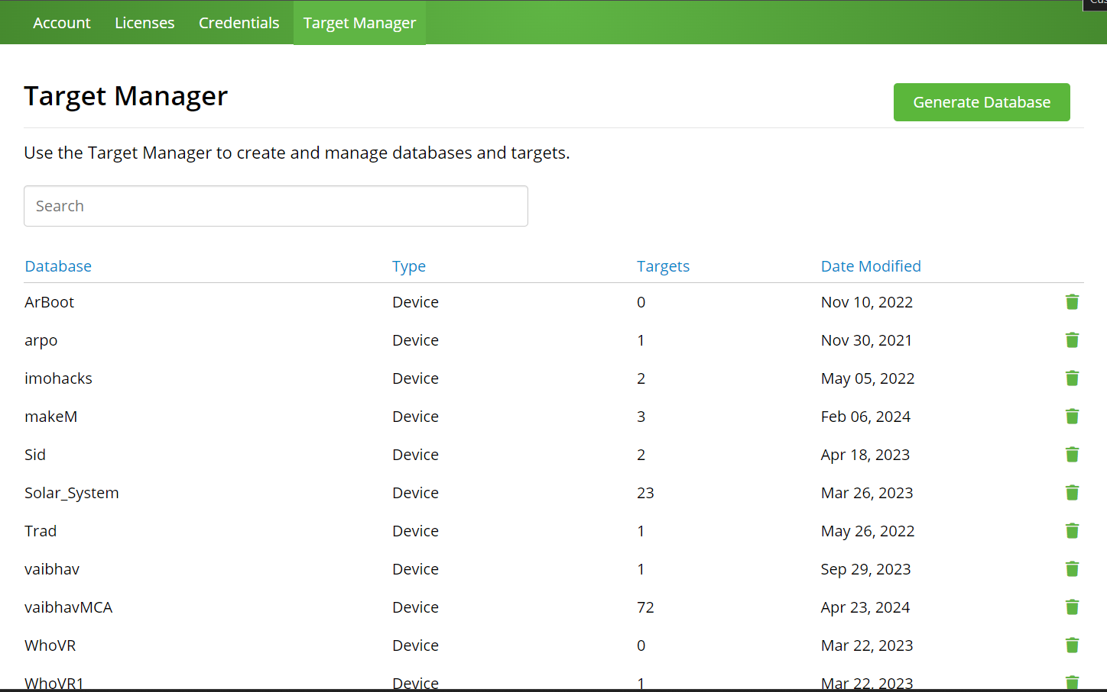

Fig 3.1: Dashboard of Admin

* 1. **USER**

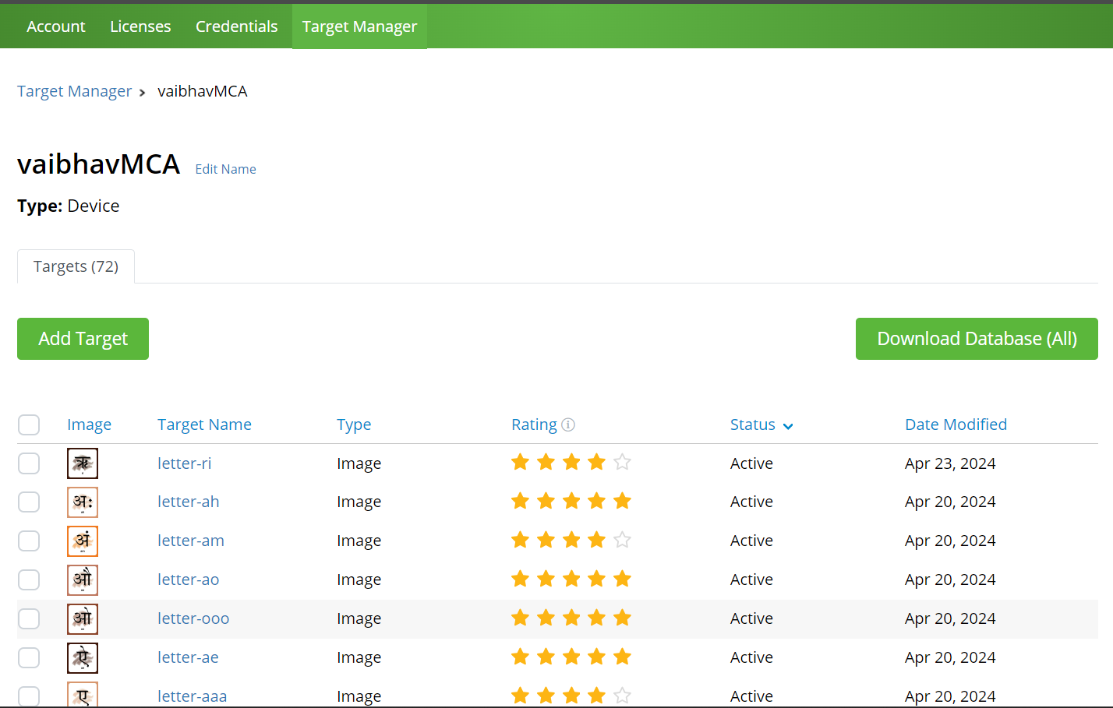

Fig 3.2: Database of User (A)

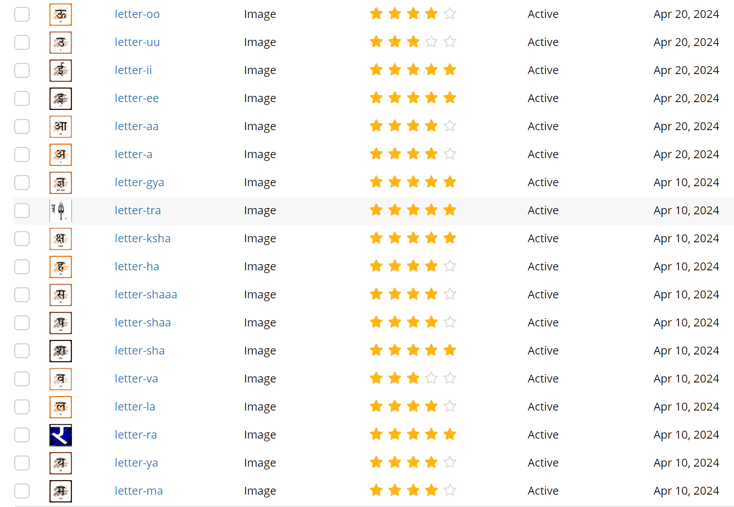

Fig 3.3: Database of User (B)

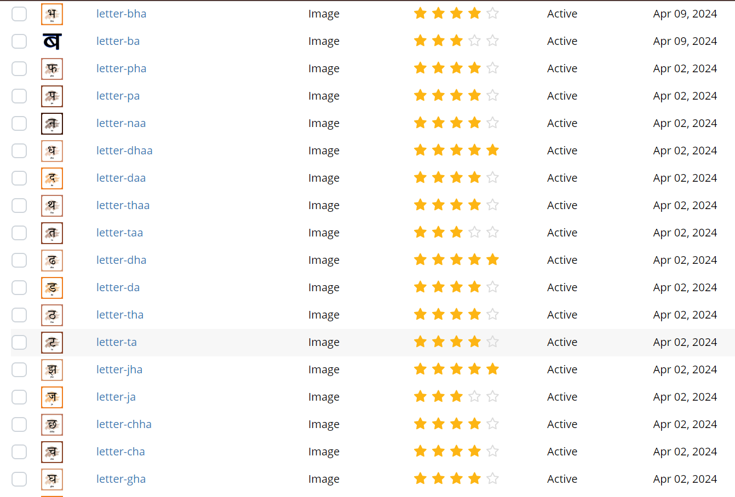

Fig 3.4: Database of User (C)

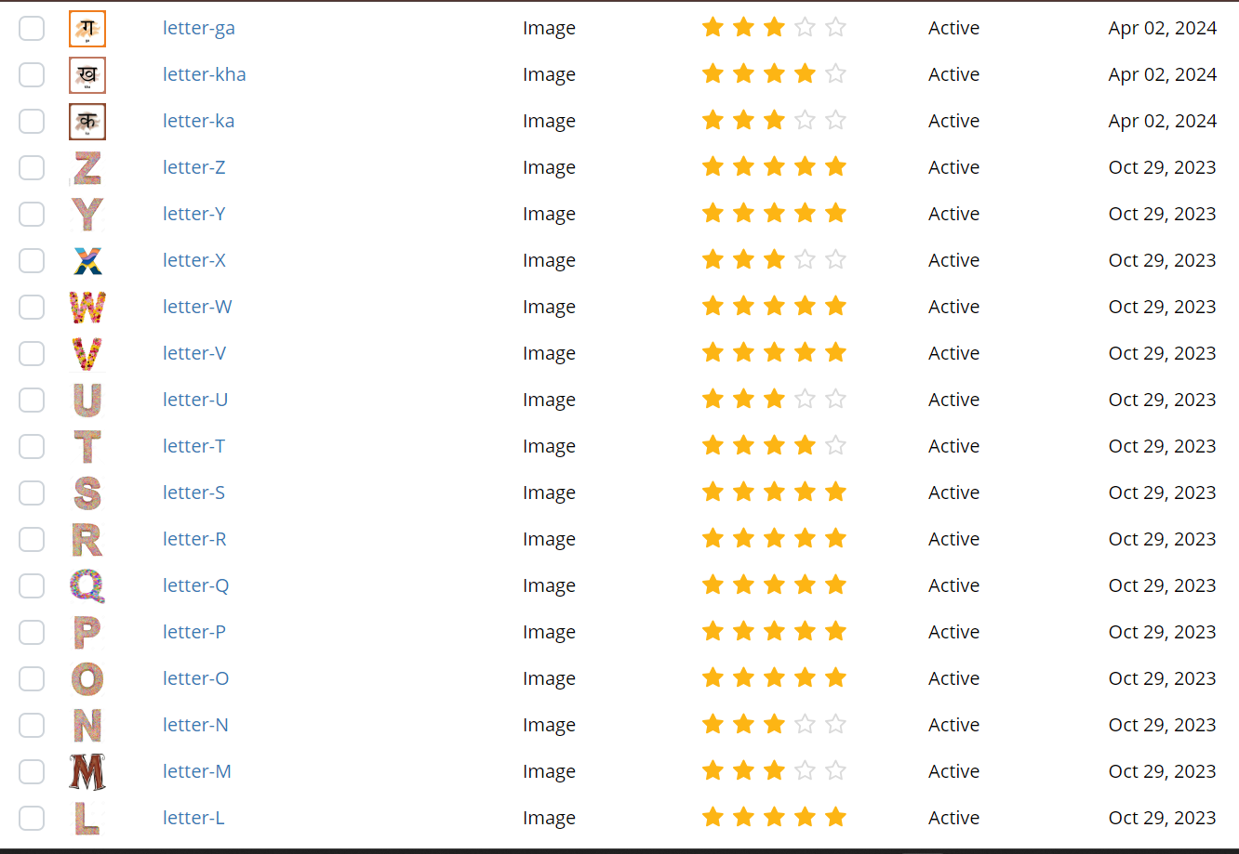

Fig 3.4: Database of User (D)

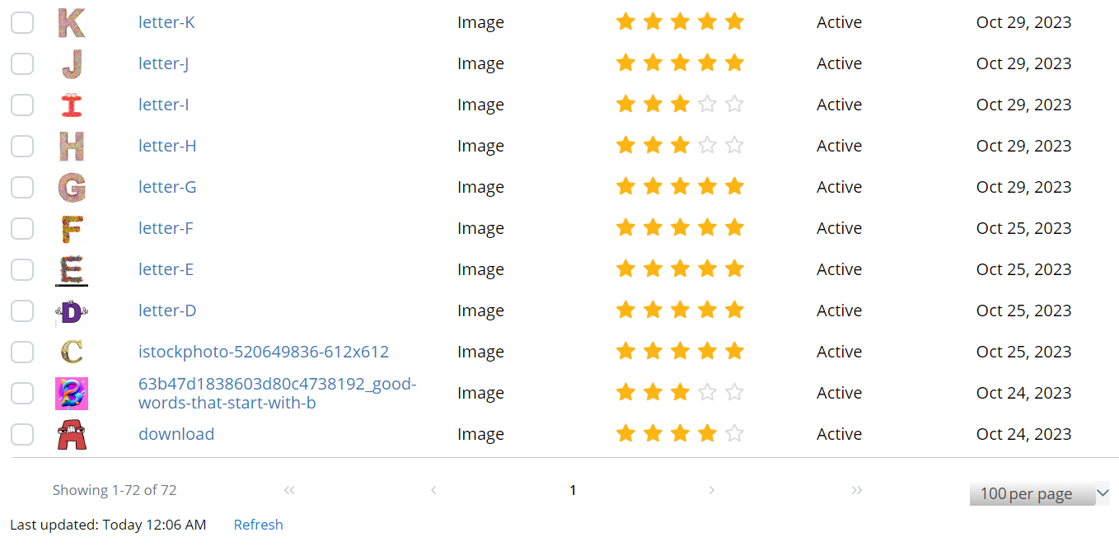

Fig 3.4: Database of User (E)

**3.4 FLOWOCHART**

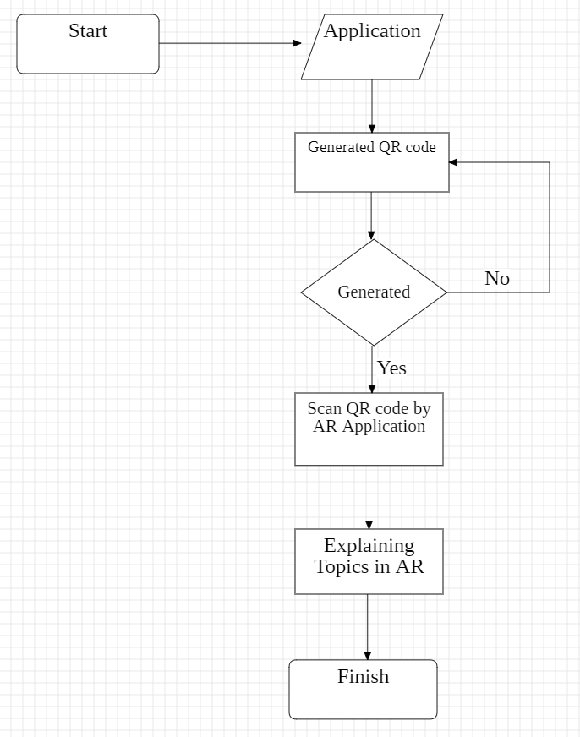

Fig 3.5: Architecture diagram of the proposed system

## CHAPTER 4

## APP DESIGN

* 1. **PROJECT SCREEN LAYOUT**

## 

Fig 4.1: Dashboard of Project

**4.2 SAMPLE SCENE**

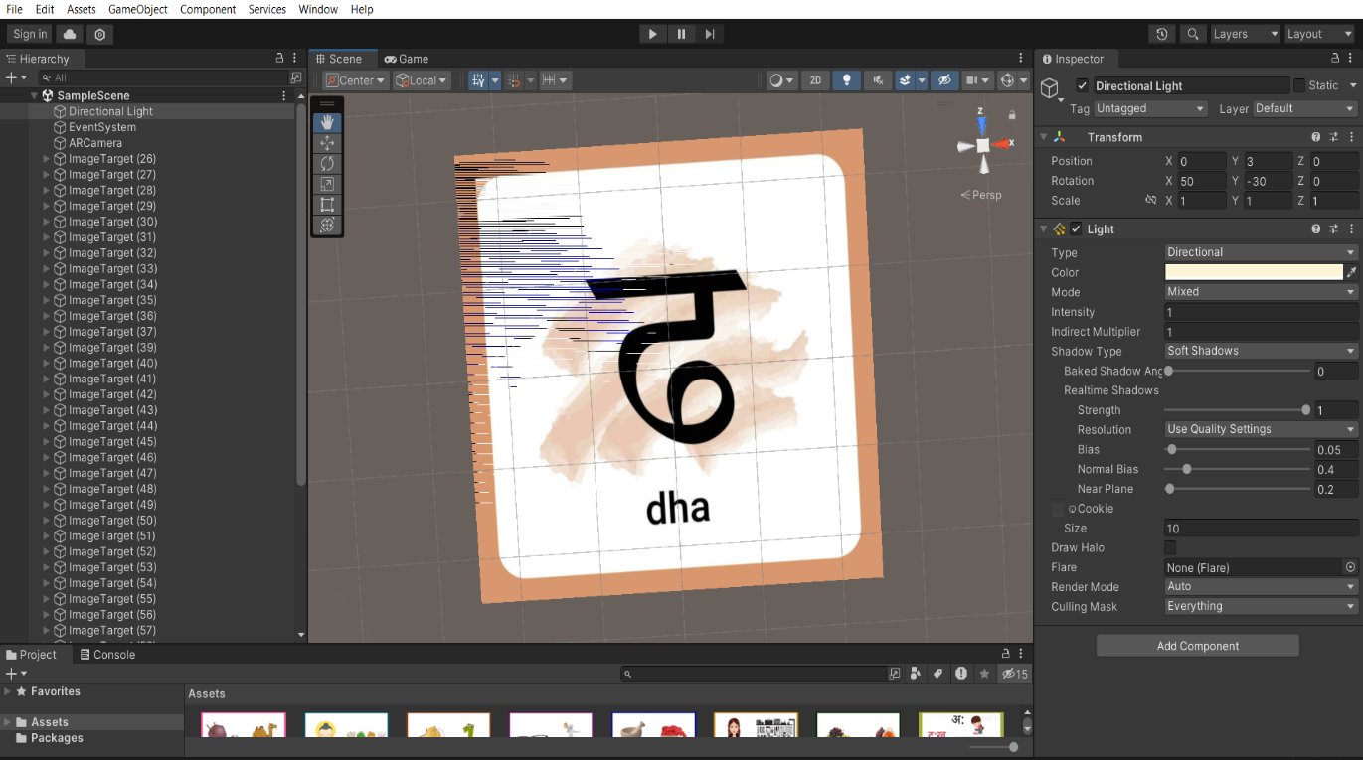

Fig 4.2: Console of Project

**4.3 DIRECTIONAL LIGHT**

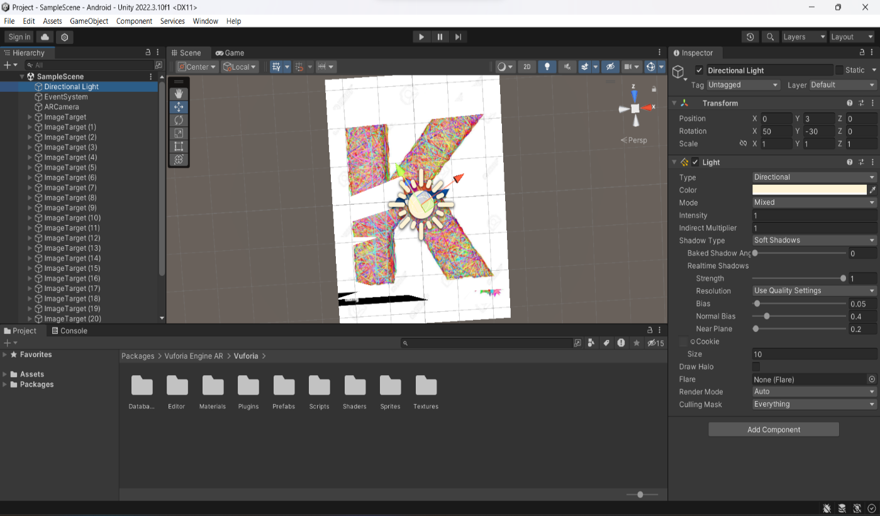

Fig 4.3: Object of project

**4.4 AR CAMERA**

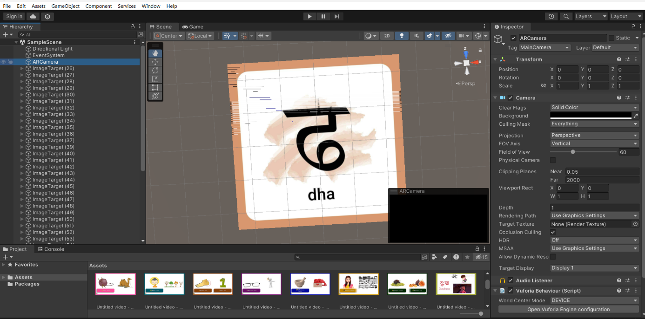

Fig 4.4: To use the camera to play video

**4.5 Image**

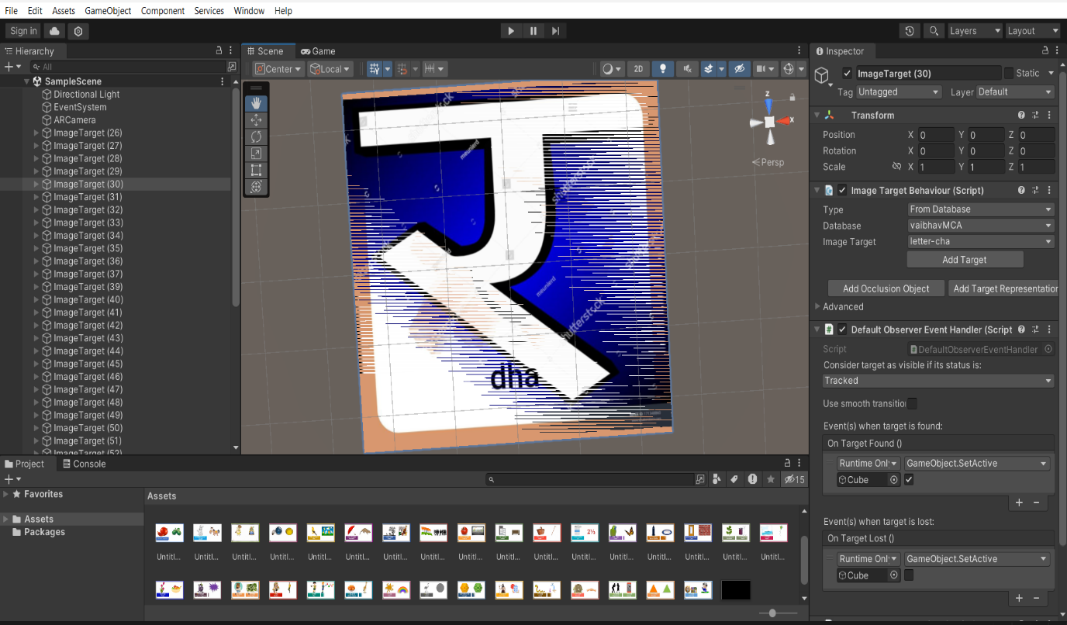

Fig 4.5: Sample Image

**4.6 Image target (1,2)**

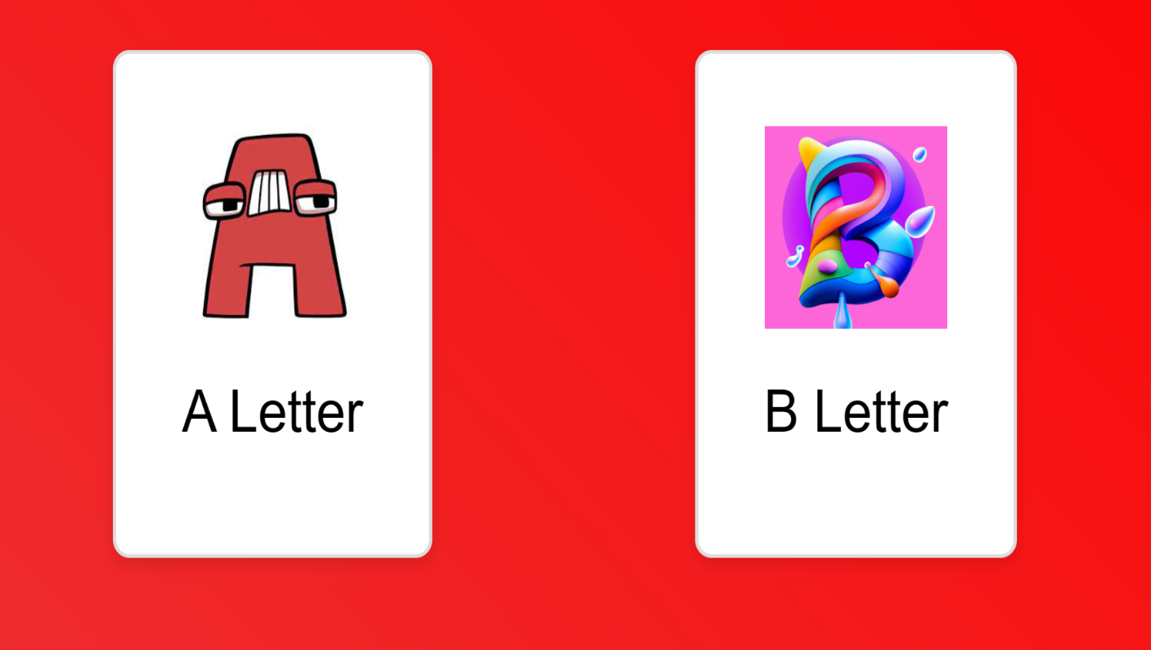

Fig 4.6: A & B Alphabet to be scan

**4.7 Image target (3,4)**

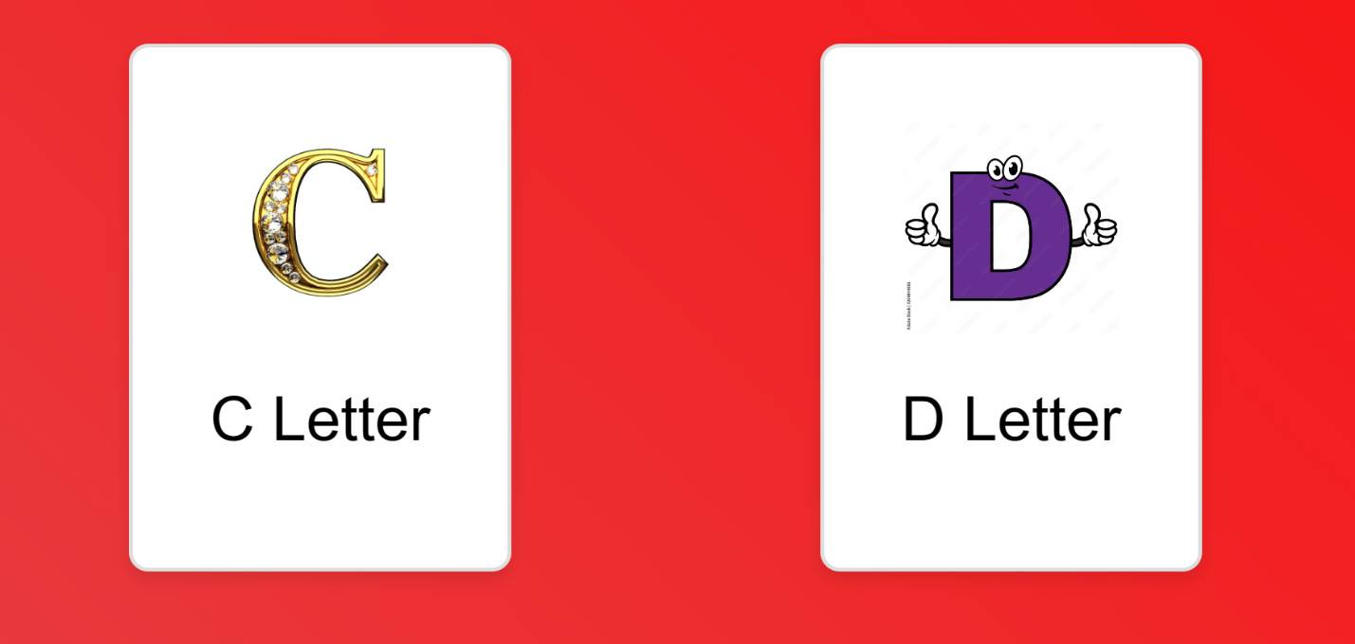

Fig 4.7: C & D Alphabet to be scan

**4.8 Image target (5,6)**

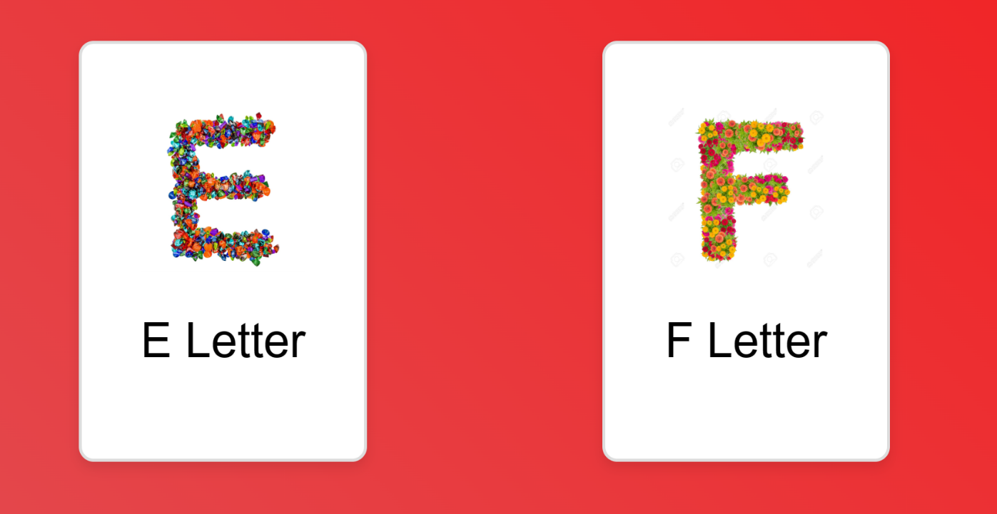

Fig 4.8: E & F Alphabet to be scan

**4.9 Image target (7,8)**

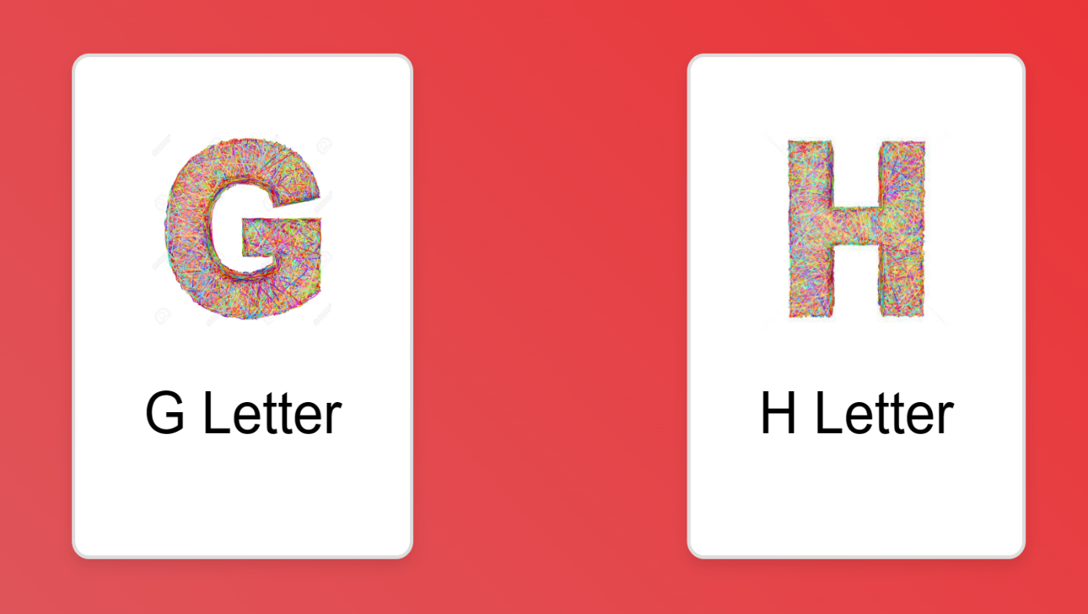

Fig 4.9: G & H Alphabet to be scan

**4.10 Image target (9,10)**

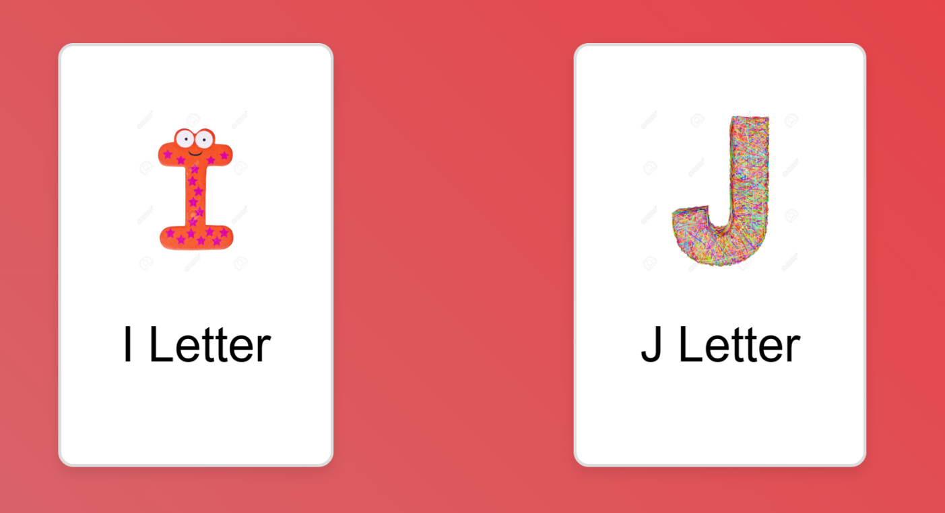

Fig 4.10: I & J Alphabet to be scan

**4.11 Image target (11,12)**

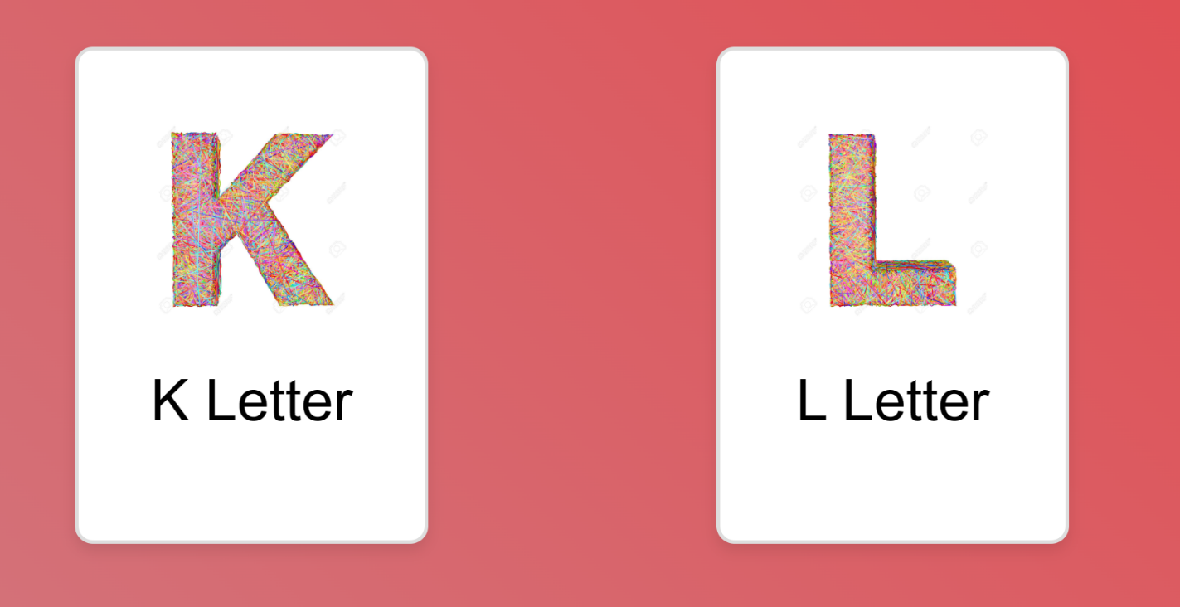

Fig 4.11: K & L Alphabet to be scan

**4.12 Image target (13,14)**

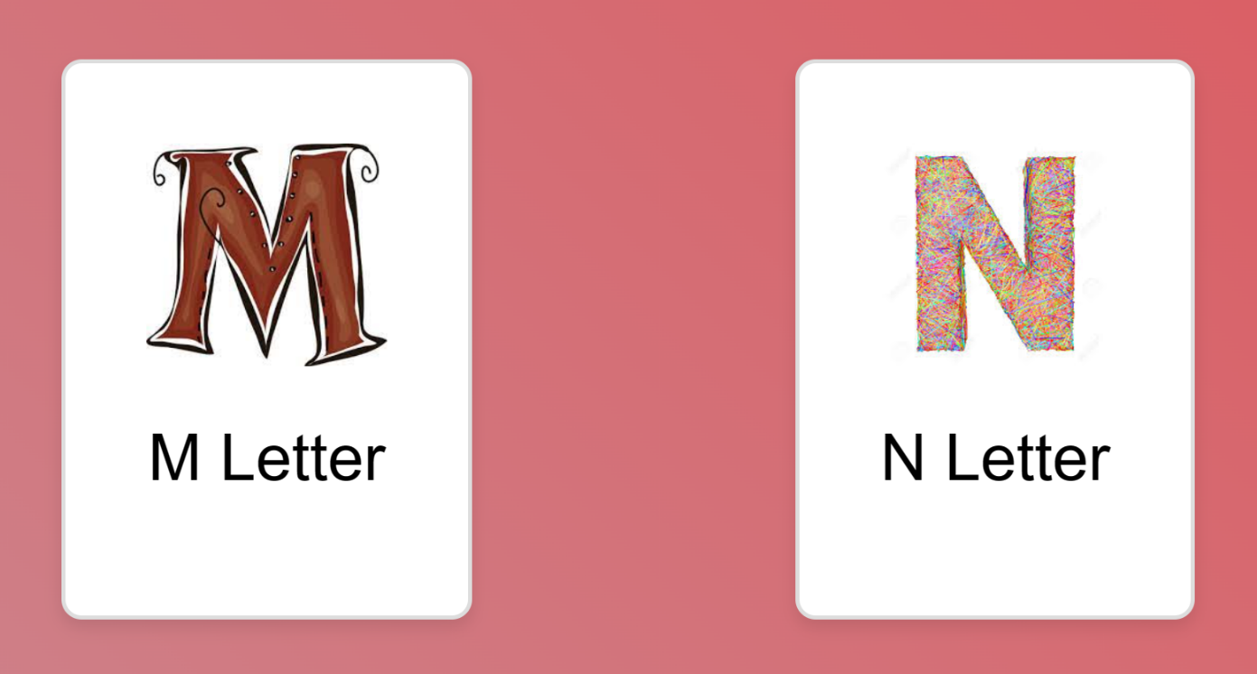

Fig 4.12: M & N Alphabet to be scan

**4.13 Image target (15,16)**

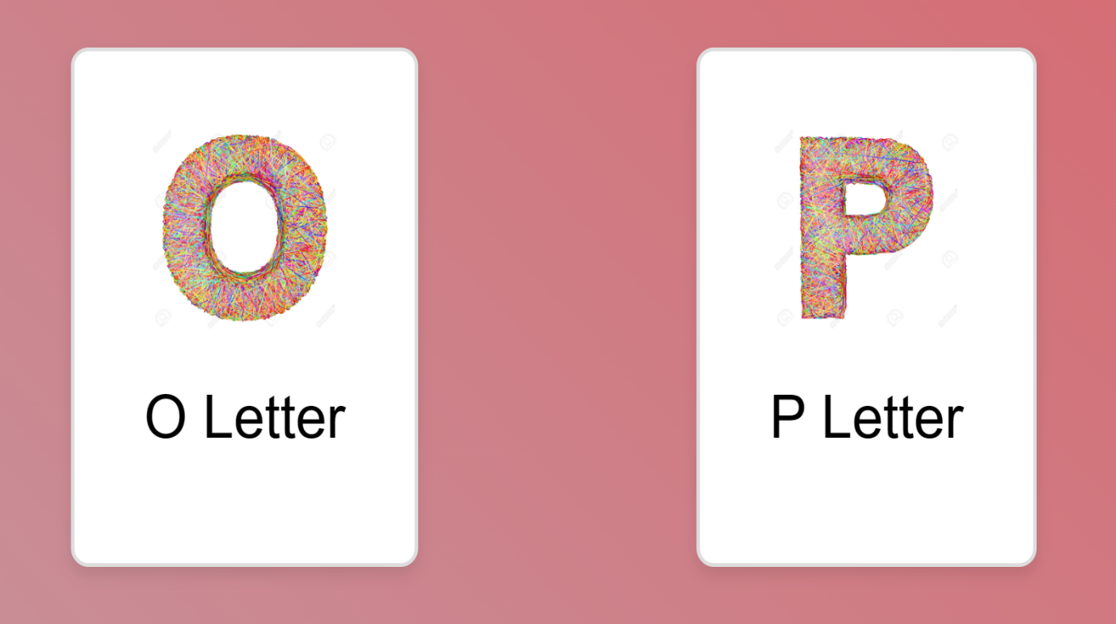

Fig 4.13: O & P Alphabet to be scan

**4.14 Image target (17,18)**

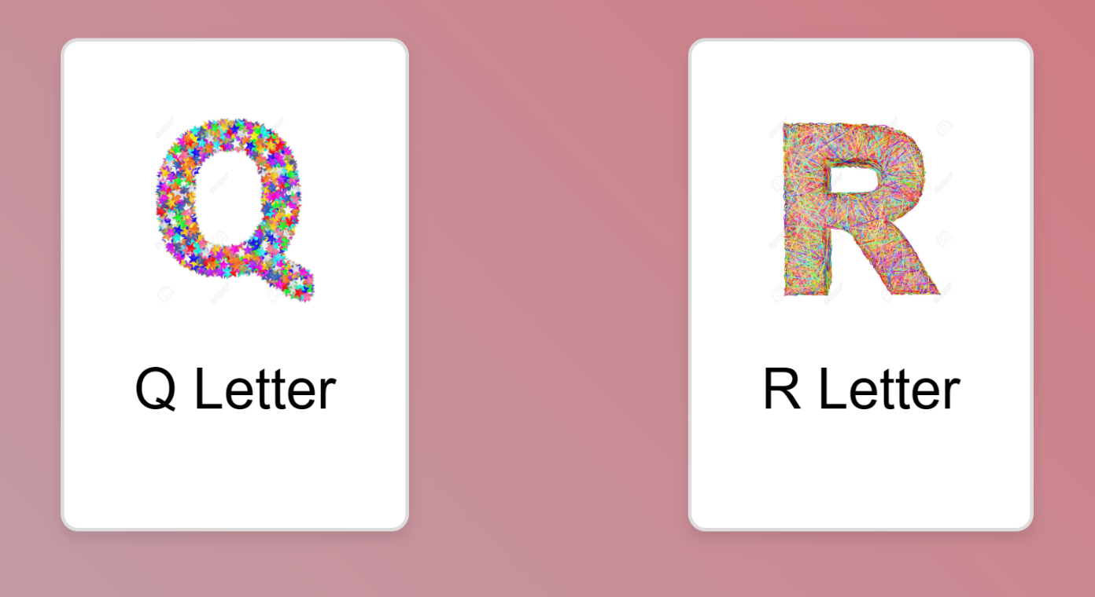

Fig 4.14: Q & R Alphabet to be scan

**4.15 Image target (19,20)**

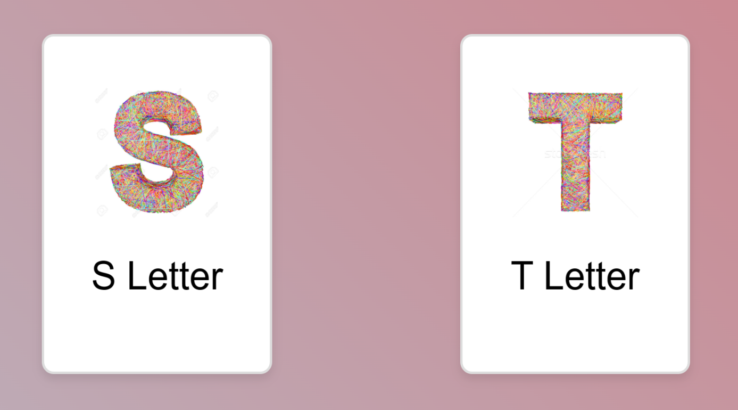

Fig 4.15: S & T Alphabet to be scan

**4.16 Image target (21,22)**

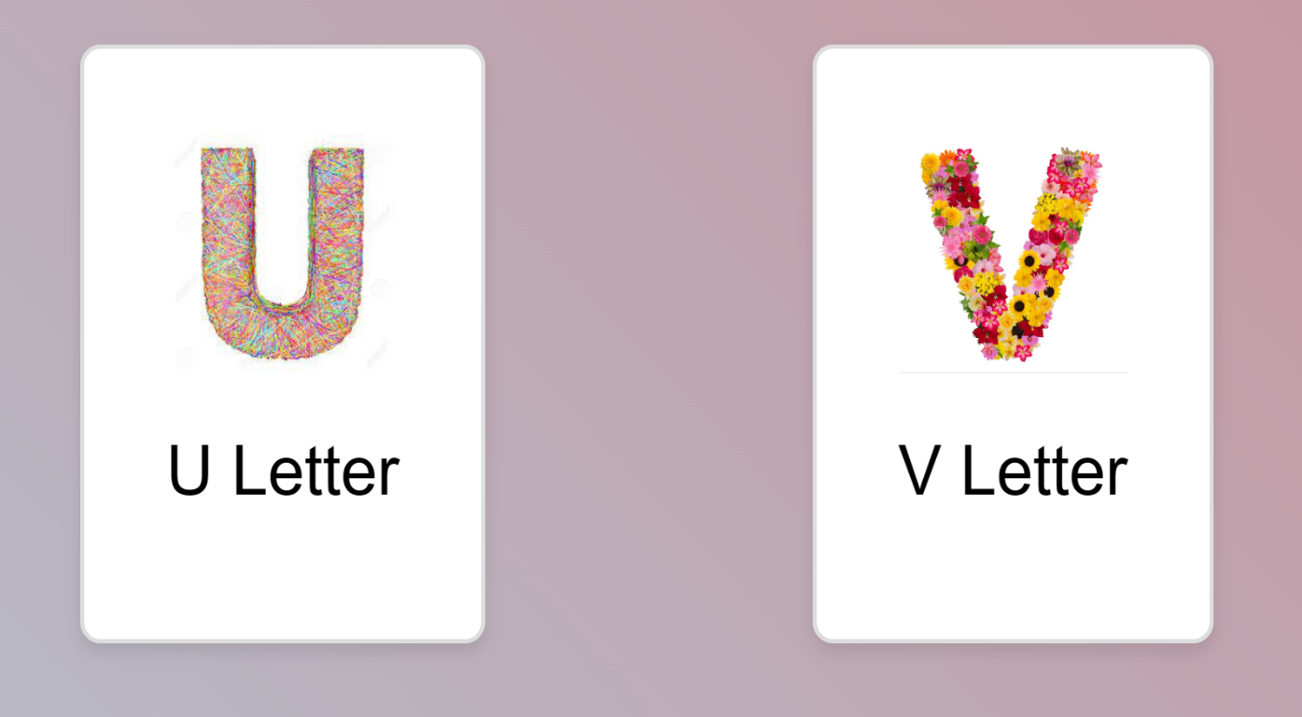

Fig 4.16: U & V Alphabet to be scan

**4.17 Image target (23,24)**

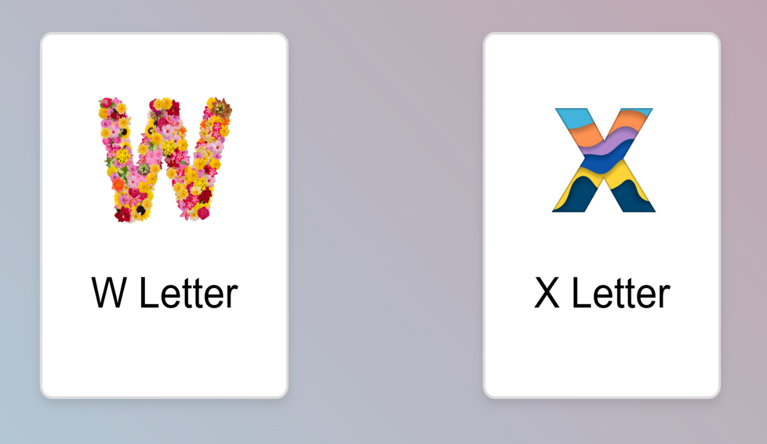

Fig 4.17: W & X Alphabet to be scan

**4.18 Image target (25,26)**

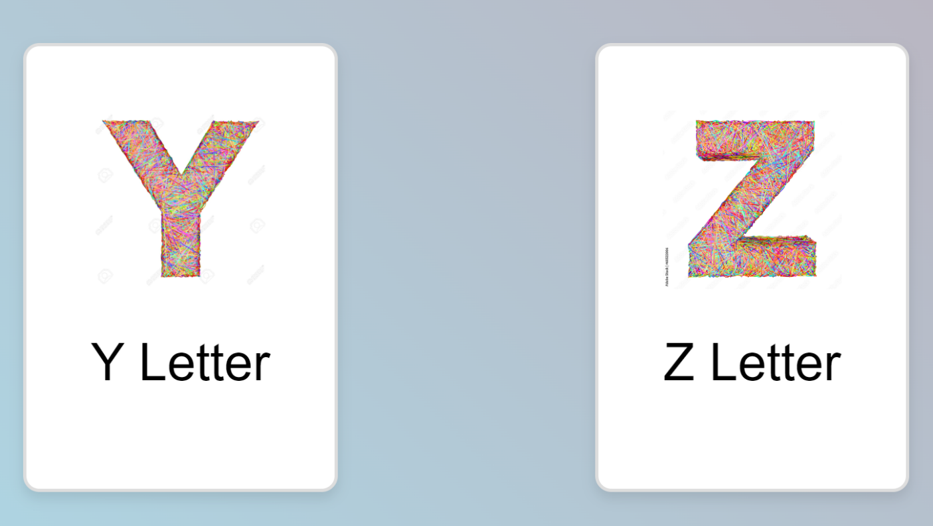

Fig 4.18: Y & Z Alphabet to be scan

**4.19 Image target (27,28)**

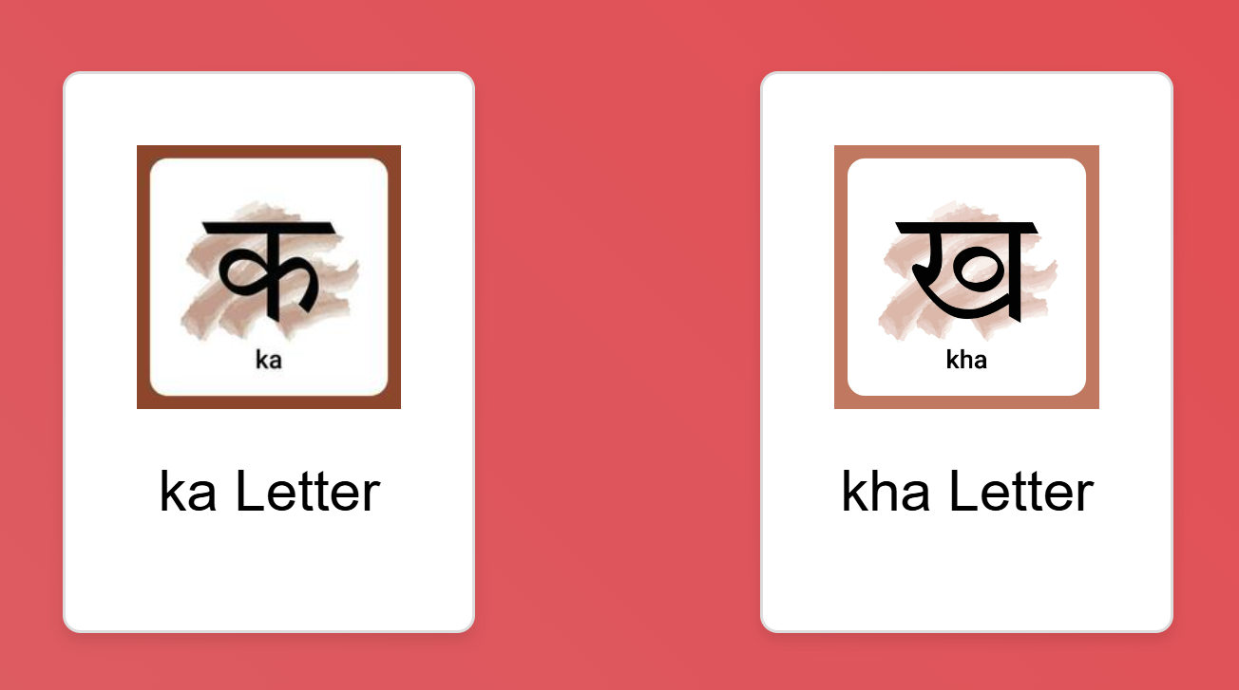

Fig 4.19: Ka & Kha Hindi Varnamala to be scan

**4.20 Image target (29,30)**

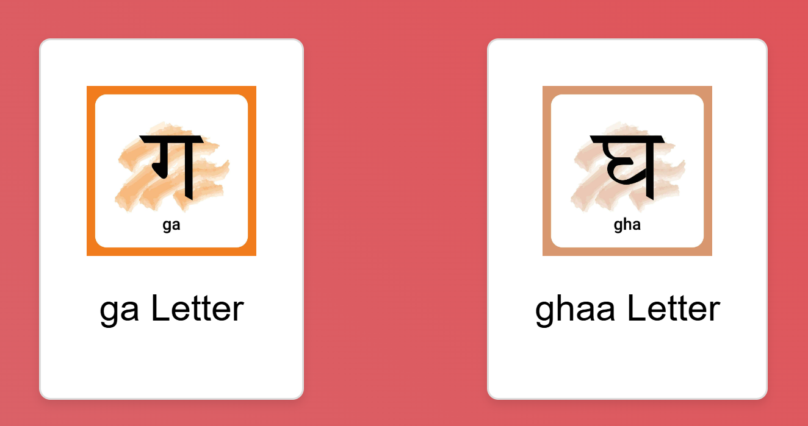

Fig 4.20: Ga & Ghaa Hindi Varnamala to be scan

**4.21 Image target (31,32)**

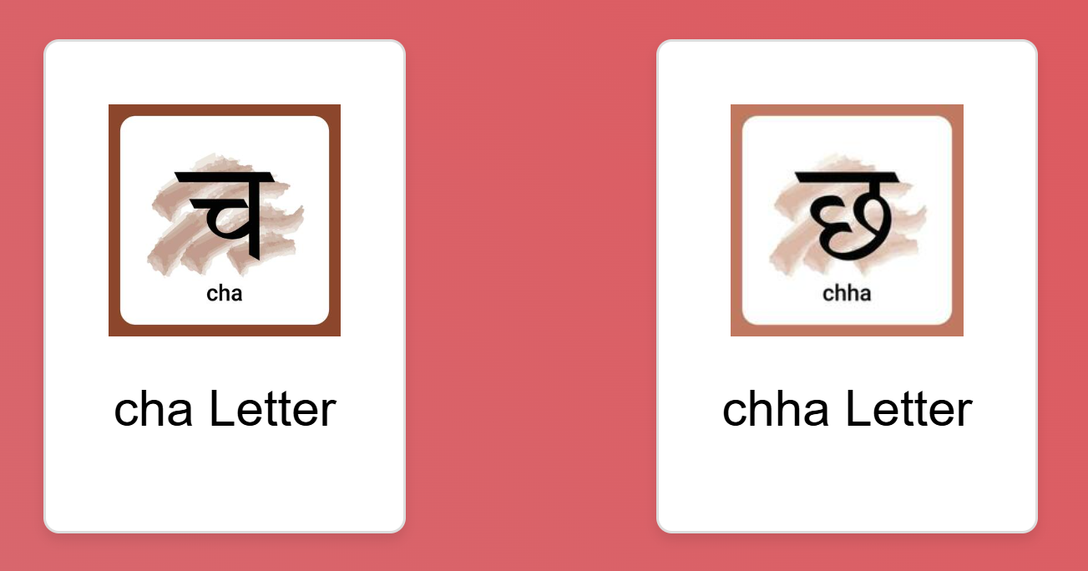

Fig 4.21: Cha & Chha Hindi Varnamala to be scan

**4.22 Image target (33,34)**



Fig 4.22: Ja & Jha Hindi Varnamala to be scan

**4.23 Image target (35,36)**

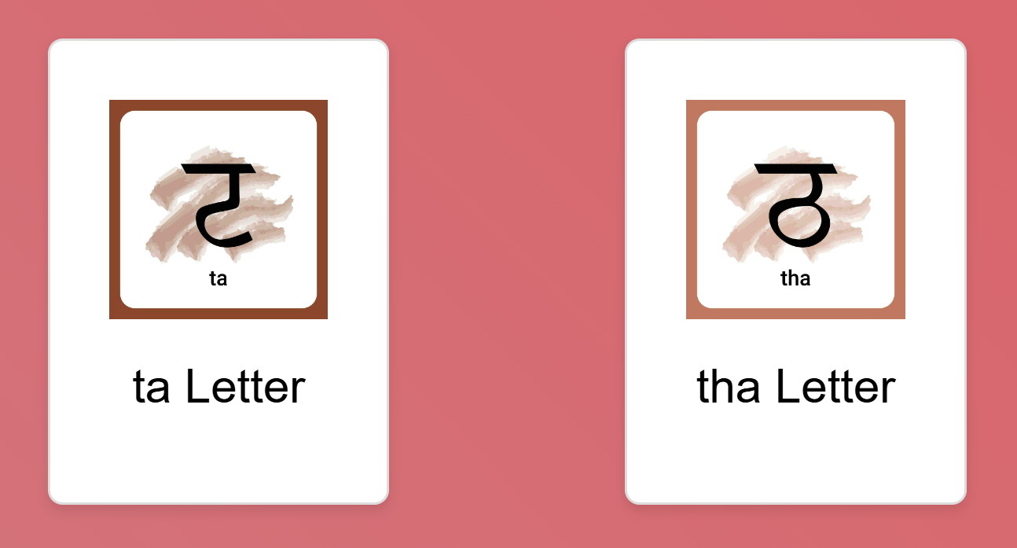

Fig 4.23: Ta & Tha Hindi Varnamala to be scan

**4.24 Image target (37,38)**

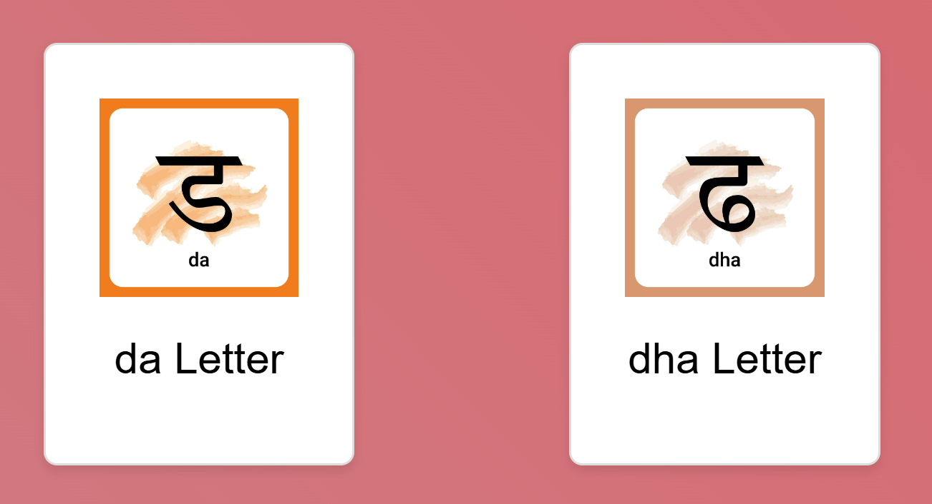

Fig 4.24: Da & Dha Hindi Varnamala to be scan

**4.25 Image target (39,40)**

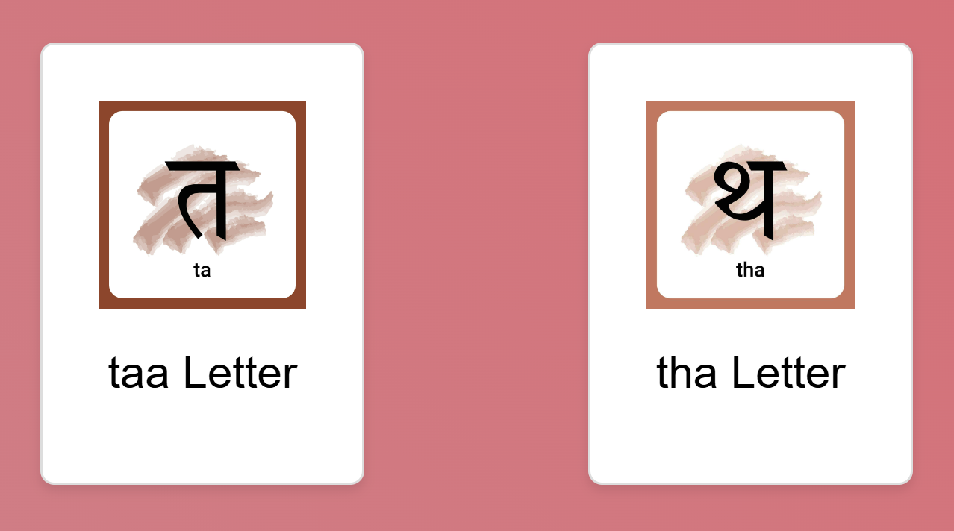

Fig 4.25: Taa & The Hindi Varnamala to be scan

**4.26 Image target (41,42)**

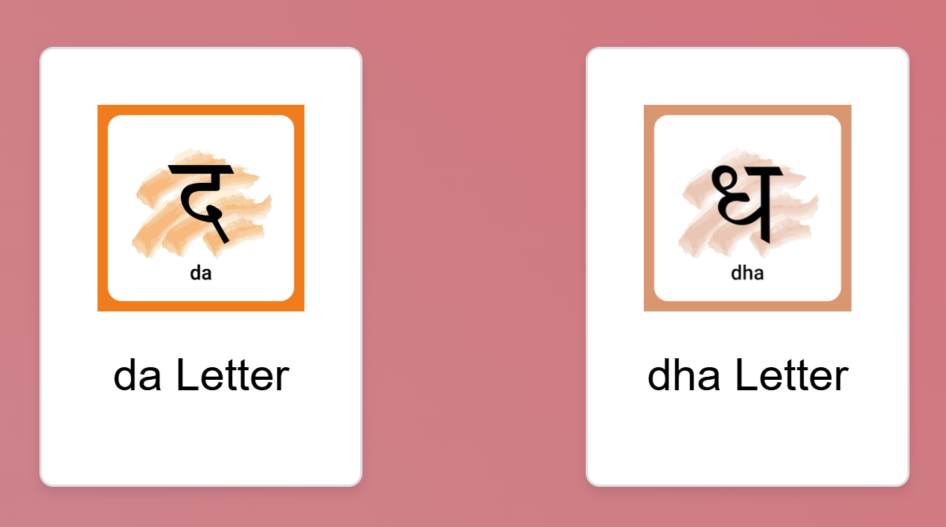

Fig 4.26: Da & Dha Hindi Varnamala to be scan

**4.27 Image target (43,44)**

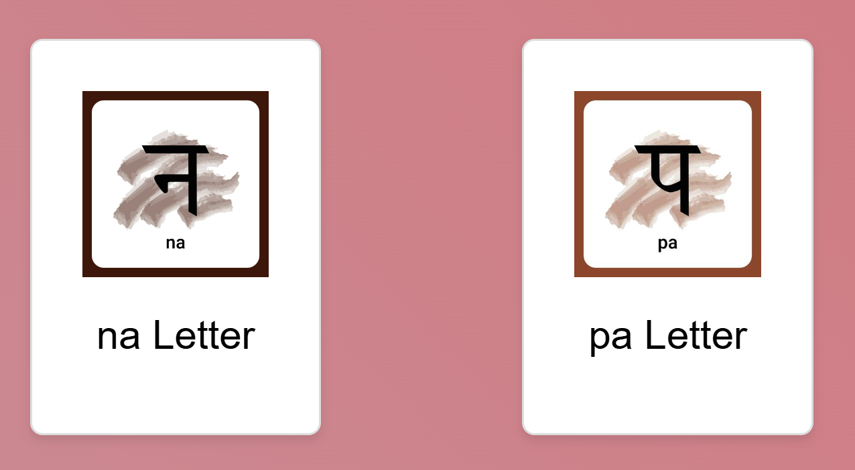

Fig 4.27: Na & Pa Hindi Varnamala to be scan

**4.28 Image target (45,46)**

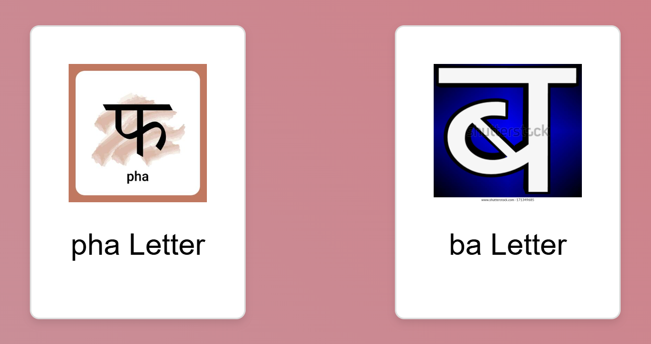

Fig 4.28: Pha & Ba Hindi Varnamala to be scan

**4.29 Image target (47,48)**

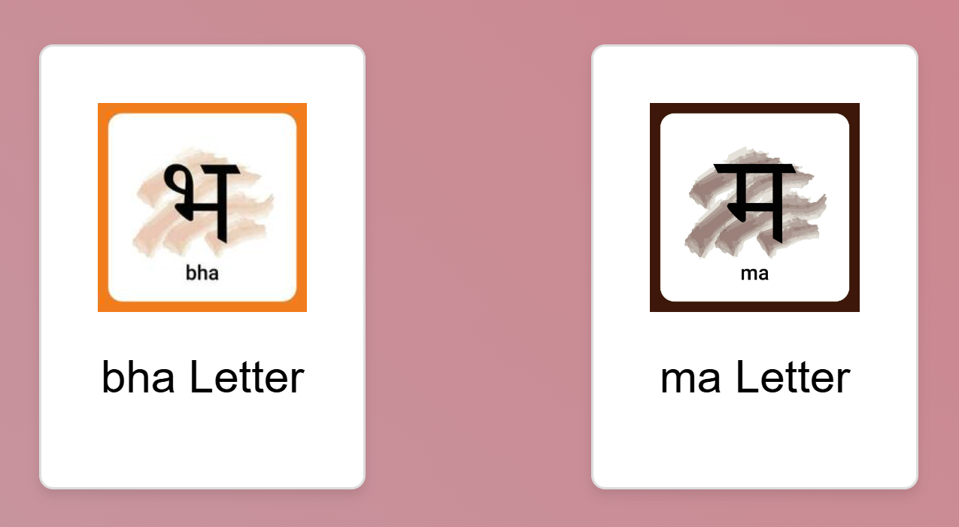

Fig 4.29: Bha & Ma Hindi Varnamala to be scan

**4.30 Image target (49,50)**

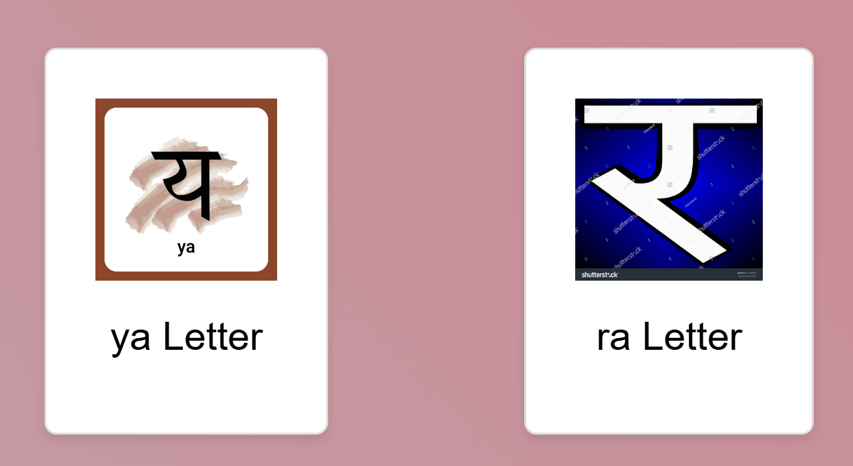

Fig 4.30: Ya & Ra Hindi Varnamala to be scan

**4.31 Image target (51,52)**

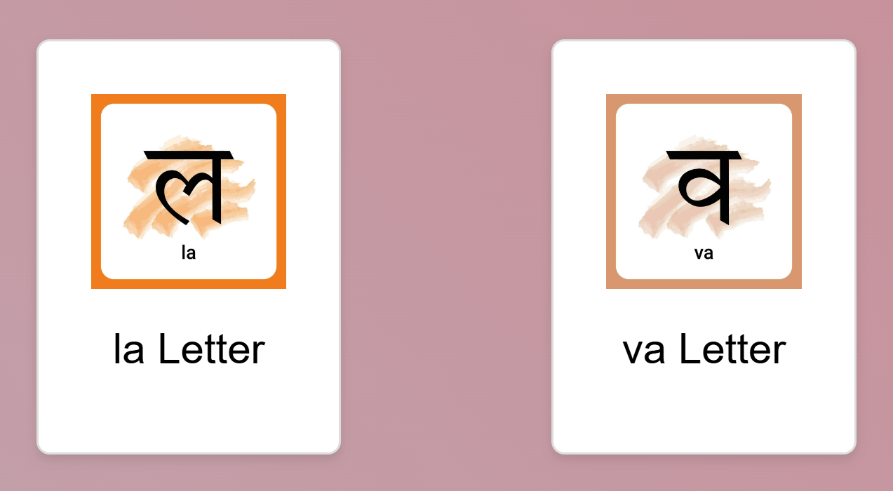

Fig 4.31: La & Va Hindi Varnamala to be scan

**4.32 Image target (53,54)**

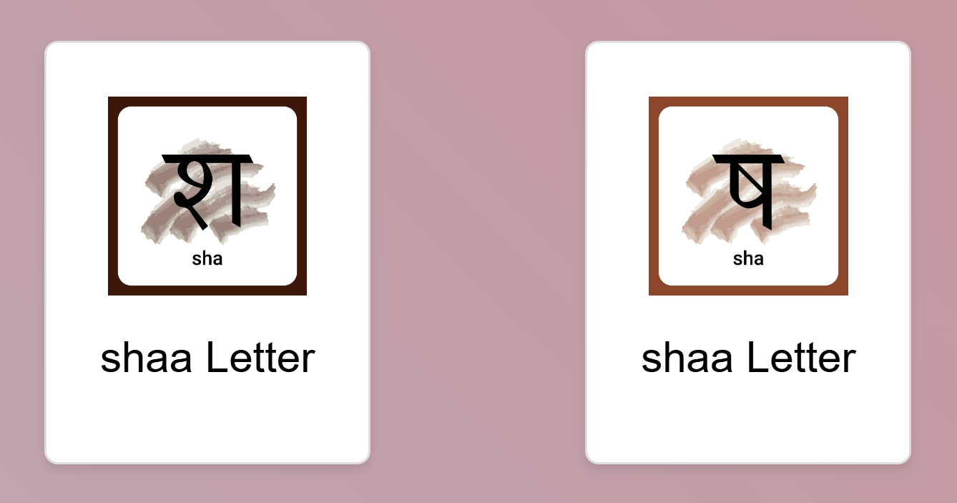

Fig 4.32: Shaa & Sha Hindi Varnamala to be scan

**4.33 Image target (55,56)**

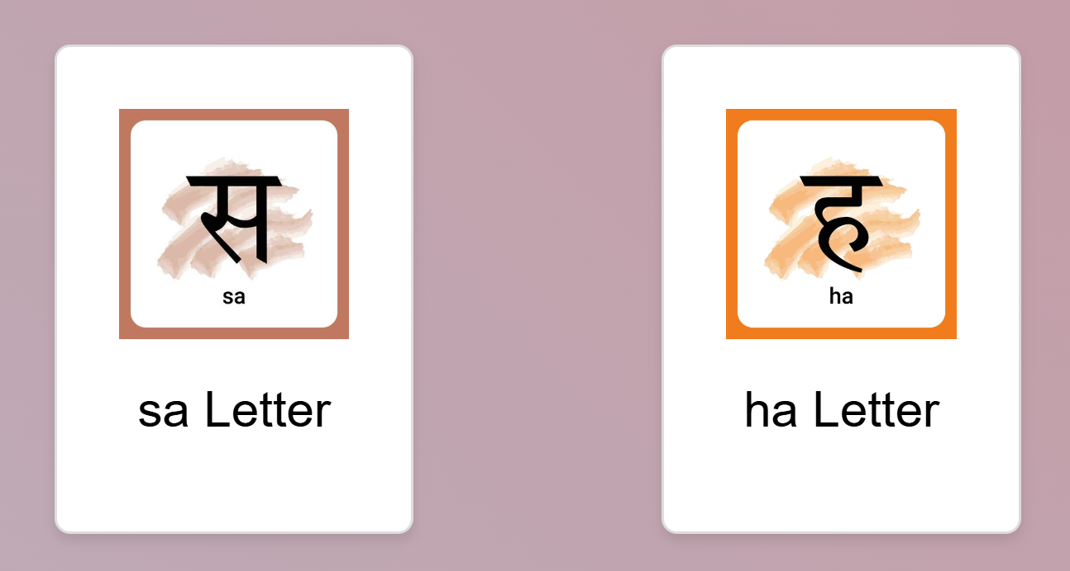

Fig 4.33: Sa & Ha Hindi Varnamala to be scan

**4.34 Image target (57,58)**

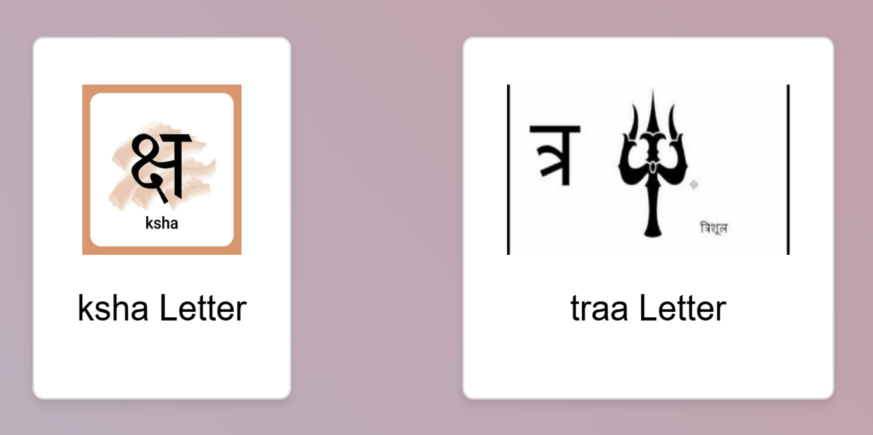

Fig 4.34: Kaha & Traa Hindi Varnamala to be scan

**4.35 Image target (59,60)**

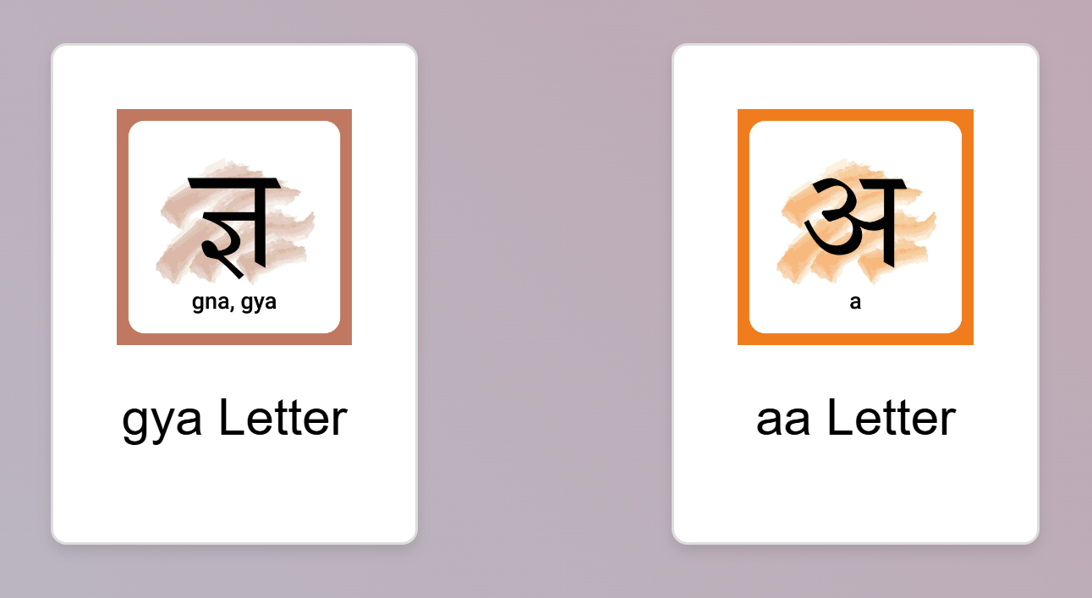

Fig 4.35: Gya & Aa Hindi Varnamala to be scan

**4.36 Image target (61,62)**

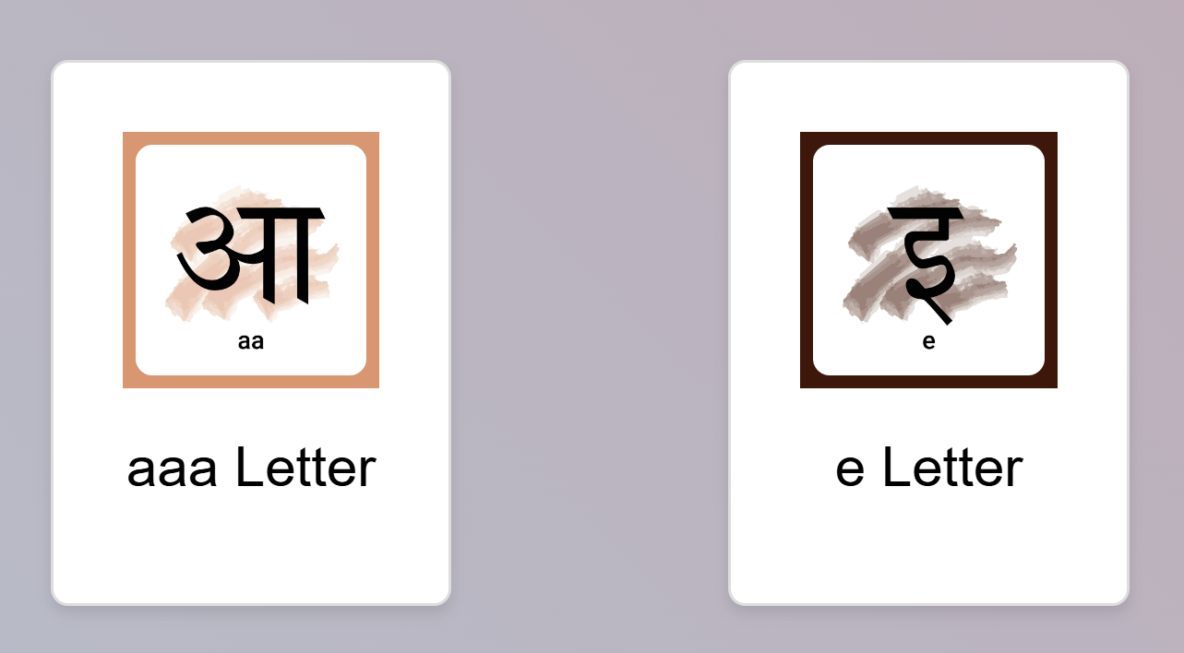

Fig 4.36: Aaa & E Hindi Varnamala to be scan

**4.37 Image target (63,64)**

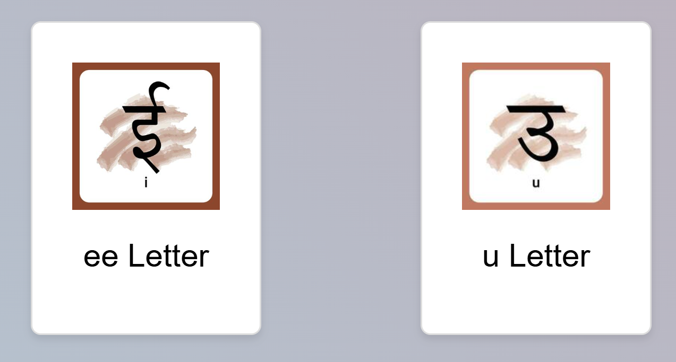

Fig 4.37: Ee & U Hindi Varnamala to be scan

**4.38 Image target (65,66)**

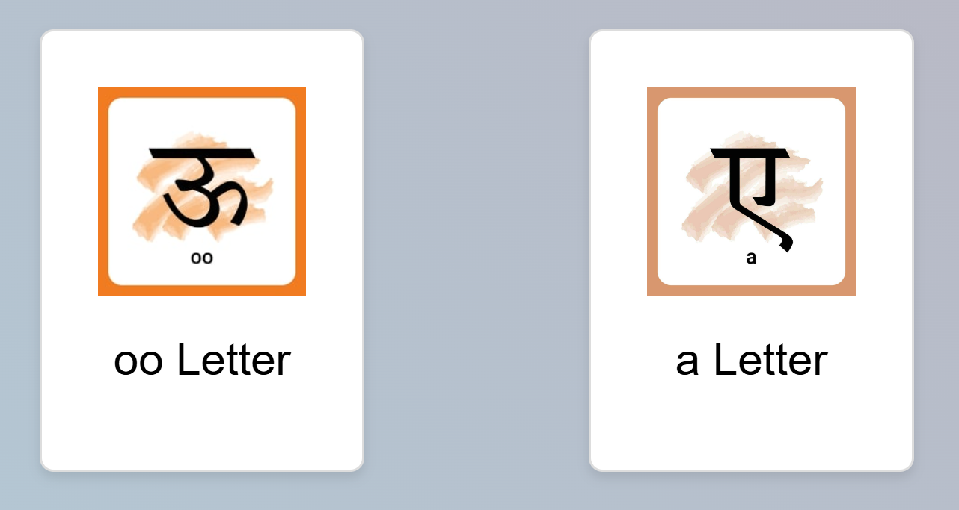

Fig 4.38: Oo & A Hindi Varnamala to be scan

**4.39 Image target (67,68)**

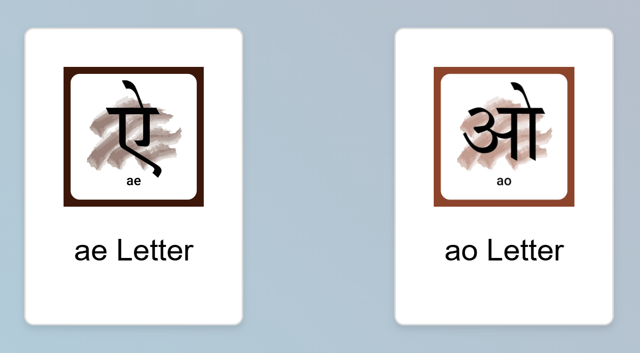

Fig 4.35: Gya & Aa Hindi Varnamala to be scan

**4.40 Image target (69,70)**

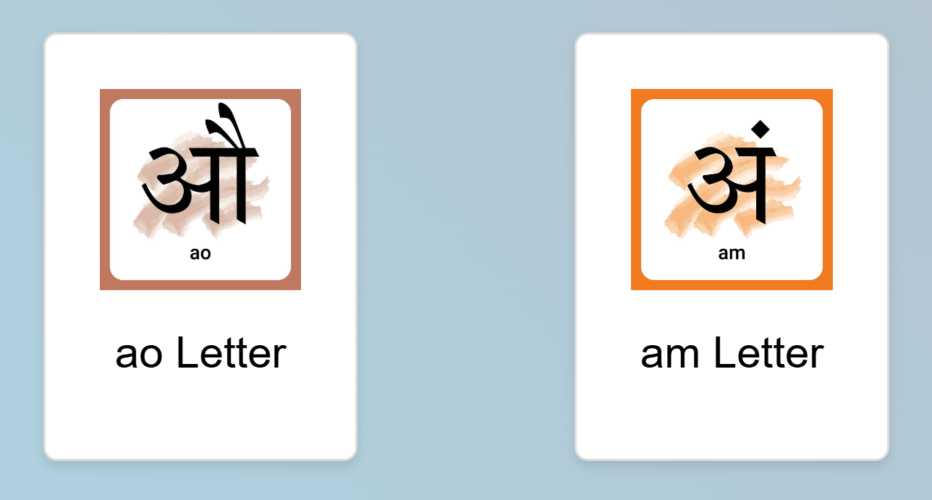

Fig 4.40: Ao & Am Hindi Varnamala to be scan

**4.41 Image target (71)**

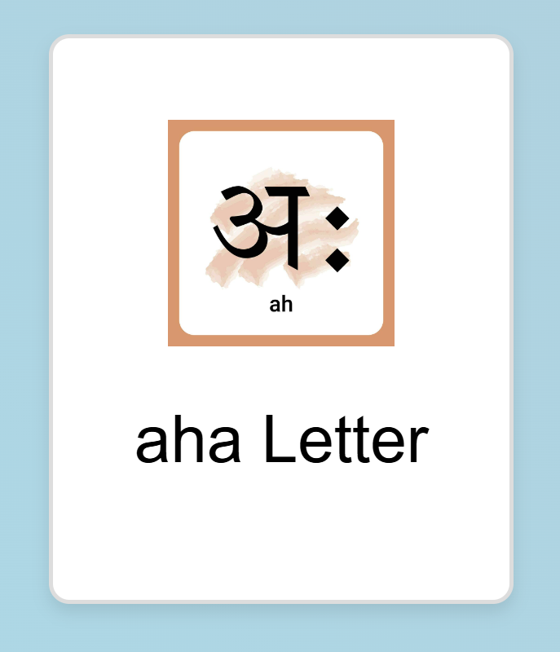

Fig 4.41: Aha Hindi Varnamala to be scan

**4.42 App setting**

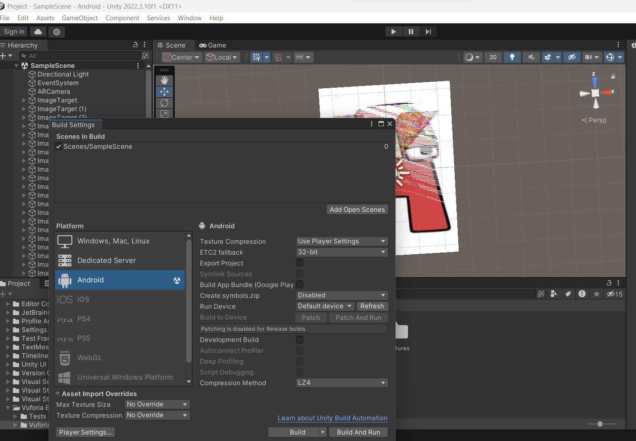

Fig 4.42: Build the app for Android

**4.43 Creative coloring studio**

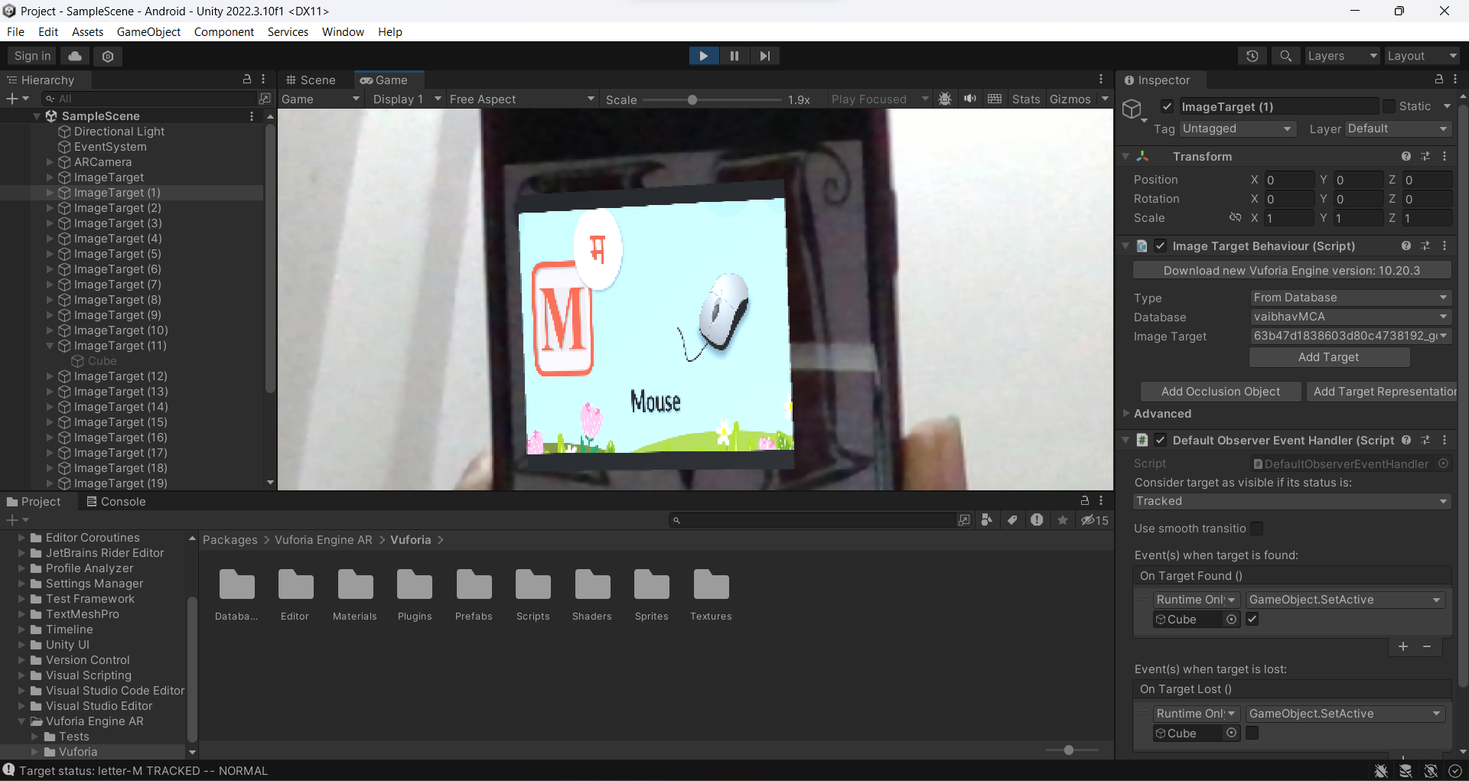

Fig 4.43: Running Project (A)

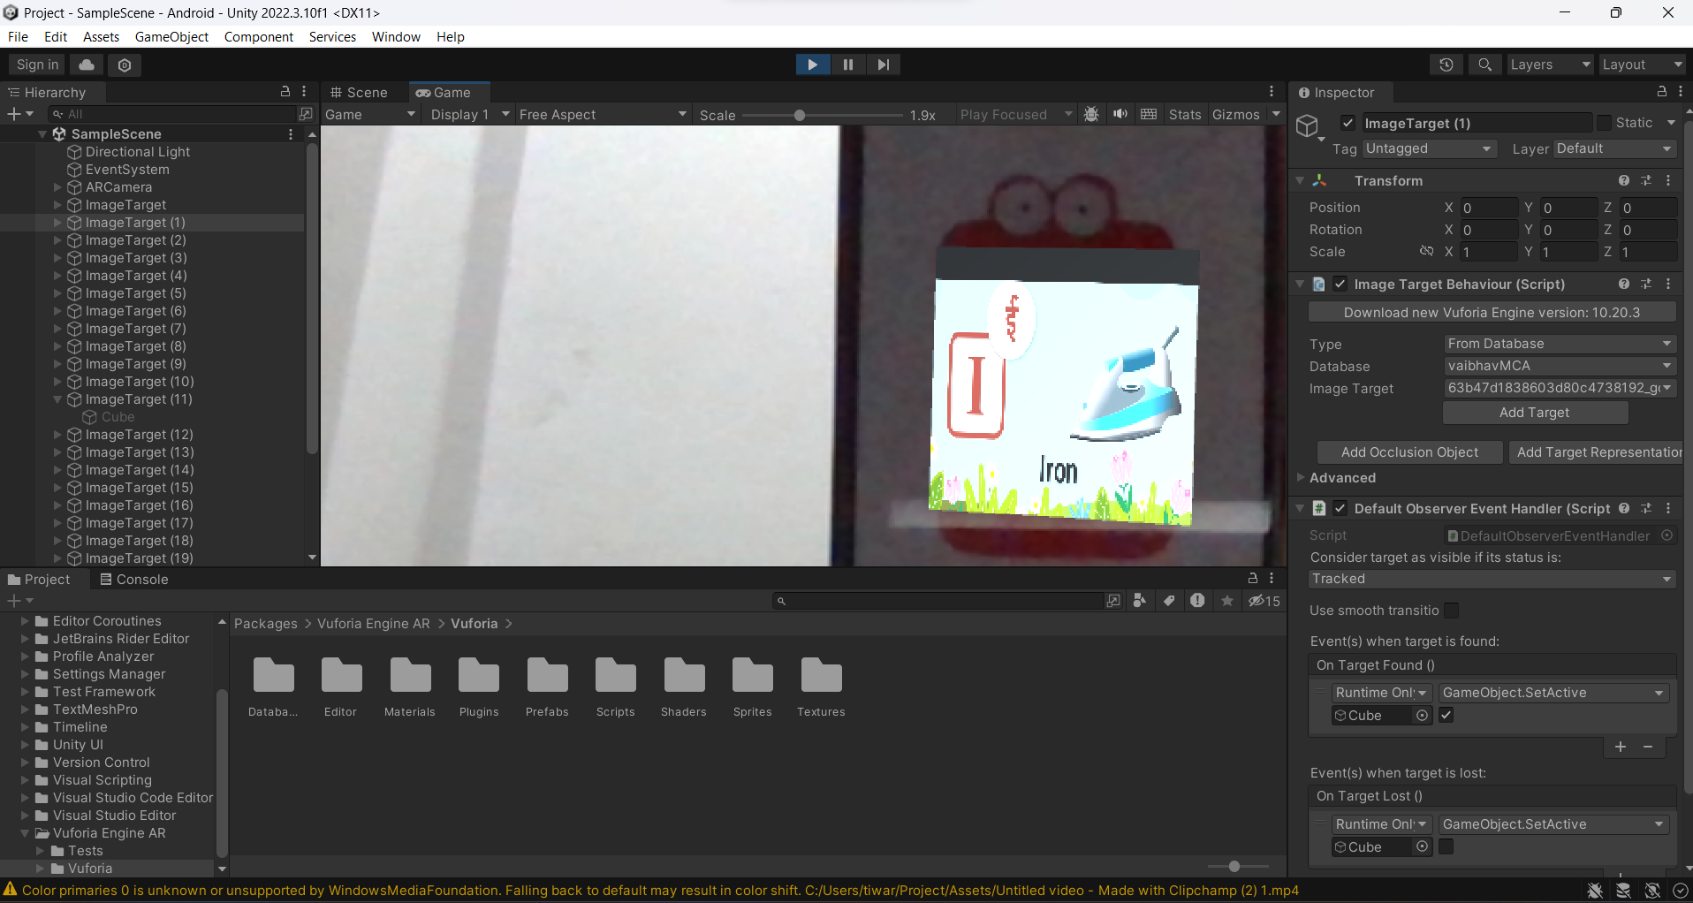

Fig 4.44: Running Project (B)

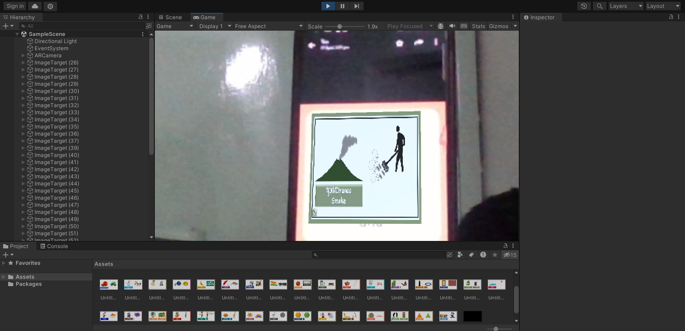

Fig 4.45: Running Project (C)

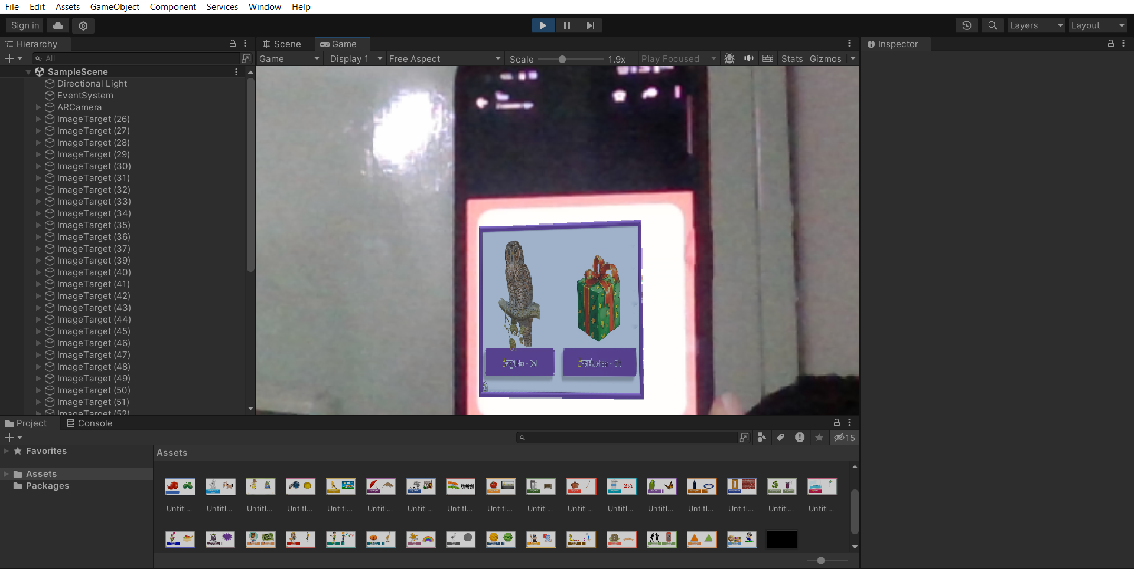

Fig 4.46: Running Project (D)

## CHAPTER 5

## TESTING

### INTRODUCTION

It seems like you're working on a Model with kids learning for learning of kids. That's a creative and interesting project! Testing is a crucial phase in software development to ensure that your application functions as intended and meets the requirements. Here are some testing considerations for your Model with Kids Learning:

### TYPES OF TESTING

**5.2.1 Functional Testing:**

1. Verify that users can create and edit books seamlessly.
2. Ensure that QR code generation and scanning work correctly.
3. Check if the interactive elements in the books (such as buttons or quizzes) function as expected.

**5.2.2 Compatibility Testing:**

1. Test your application on different devices and browsers to ensure cross-platform compatibility.
2. Check compatibility with various screen sizes and resolutions.

**5.2.3 Performance Testing:**

1. Assess the application's loading times for books and QR code processing.
2. Check for memory leaks or performance issues, especially on devices with lower specifications.

**5.2.4 Usability Testing:**

1. Evaluate the user interface for simplicity and ease of use, especially for kids.
2. Get feedback from potential users, and make adjustments based on their input.

**5.2.5 Security Testing:**

1. Ensure that the QR code generation and scanning processes are secure.
2. Validate input to prevent any vulnerabilities or exploits.

**5.2.6 Error Handling:**

1. Test how the application handles various error scenarios, such as invalid QR codes or network issues.
2. Implement meaningful error messages to guide users.

**5.2.7 Accessibility Testing:**

1. Confirm that the application is accessible to users with disabilities.
2. Test with screen readers and ensure proper keyboard navigation.

**5.2.8 Load Testing:**

1. If your application will have a significant number of users, perform load testing to ensure it can handle the expected load without performance degradation.

**5.2.9 Collaborative Testing:**

1. Conduct testing with a group of kids or educators to get real-world feedback and understand how well the application meets educational needs.

**5.2.10 Cross-Browser Testing:**

1. Verify that your application works consistently across different web browsers.

Remember to conduct both manual and automated testing to cover a broad range of scenarios. Regularly update and iterate on your testing plan as you receive feedback and make improvements to your Unity-based online book creator.

# CHAPTER 6

## CONCLUSION

The “**Model with Kids Learning”** has reached its conclusion, marking a significant achievement in educational technology. This innovative project aimed at enhancing children's learning experiences through interactive and engaging content.

The modules are completed as a platform for developing each word explanations in this system using augmented reality and also the android application with an interactive user interface. Students can use this application for understanding concepts and students get more interesting and interactive concepts here. The contribution of AR in providing the demonstration of Image, video, 3D model explanations with audio clip it helps in making the understandability much easier to student and interactive. Henceforth, this implementation leads to a new opportunity to understand complex words into a convenient platform and reduce the difficulty in learning about the books and also provides a better learning experience. Further enhancement of the application would be implementing the other chapter explanations with 3D modules. And further, it can be developed for other subjects also like mathematics, social science and EVS. An application can be further enhanced to the cross-sectional view of different subjects. which will be very useful to students. Also, further, it can be developed for complete chapter explanation it will help the student to learn interactive and interesting mode.

**6.1 GOALS ACHIEVED**

1. Interactive Learning Modules
2. User-Friendly Interface
3. QR Code Integration
4. Through Testing and User Feedback
5. Security Measures
6. Documentation and Support
7. Successful Deployment
8. Post-Launch Monitoring

As the project concludes, the focus shifts towards maintaining the app's excellence and responsiveness to the evolving needs of its users. The Kids Learning App stands as a testament to the power of technology in making education both fun and effective for children, paving the way for future innovations in the field of edutainment.

# CHAPTER 7

# REFERENCES

[1] B. Siregar, F. Syahputra, U. Andayani, Abdul Gani, M. F. Syahputra, M. B. Siregar, Abdul Gani “Augmented for Respiratory system using Leap Motion Controller”, International Conference of Science, Technology, Engineering, Environmental and Ramification Researches, 2018, pp.1900-1904.

[2] Francesca Beatrice, Juan Cano, Caramen Juan, “An Augmented Reality System for Learning the Interior of the science”, 8th IEEE International Conference on Advanced Learning Technologies, 2008, pp.186-188.

[3] Chien-Huan Chien, Tay-Sheng Jeng, “An Interactive Augmented Reality System for Learning Anatomy Structure”, Proceedings of Multiconference of Engineers and Computer science, 2010, pp.978-988.

[4] Andreas Rienow, Carsten Jürgens Claudia Lindner, Augmented Reality applications as digital experiments for education – An example in the Earth-Moon System, 2019, DOI:

[5] Gunawan Witjaksosno, Michael H., Kurniawan, Suharjito, Diana “Science Learning Systems Using Augmented Reality on Mobile Application”, 3rd International Conference on Computer Science and Computational Intelligence: Empowering Smart Technology in Digital Era of Better Life”, 2018, pp.80-88.

[6] Muhammed kofoglu, c Dargut, Reyhane Arslan, “Development of Augmented Reality Application for Biology Education” in Journal of Turkish Education, volume 7, Issue 1, March 2020